|  |
| --- |
| **SUMMER COOL DAIRIES**    **A Skill Oriented Course Web Application report**    Submitted in the partial fulfilment of the requirements for    the award of the degree of    Bachelor of Technology  In  Computer Science and Engineering  by    **RAVULAPATI KIRANMAI**  **21761A05B8**    Under the guidance of  Dr. K. Devi Priya,  Associate Professor, Dept. of CSE        **Department of Computer Science and Engineering**  **Lakireddy Bali Reddy College of Engineering (Autonomous)** **Accredited by NAAC & NBA (Under Tier - I)**  **Affiliated to JNTUK, Kakinada; ISO 9001:2015 Certified** **2022-23** |

1 | P a g

1

|

P a g e

**Certificate**

This is to certify that the 20CSS2

-

Web Application Development

using Full Stack Module-II

-

(Backend Development) Skill Oriented Course entitled “

**Summer Cool Dairies**

“ is being submitted by

**Ravulapati Kiranmai**

**,**

**21761A05B8**

in partial fulfilment for the award of B. Tech in

Computer Science & Engineering to the Jawaharlal Nehru Techn

ological University Kakinada is a

record of bonafide work carried out by her/him under my guidance.

The results embodied in this Skill Oriented Course Web Application / Project report have

not been submitted to any other University or Institute for the a

ward of any degree or diploma.

**Project Guide**

**Head of the department**

Dr. K Devi Priya

Dr. D. Veeraiah,

Associate Professor.

Professor.

**External Examiner**

**LAKIREDDY BALI REDDY COLLEGE OF ENGINEERING**

**)**

**AUTONOMOUS**

**(**

**Accredited by NAAC with ‘A’ Grade & NBA (Under Tier**

**-**

**I), ISO 9001:2015 Certified Institution**

**Approved by AICTE, New Delhi and Affiliated to JNTUK,**

**Kakinada**

**L.B. REDDY NAGAR, MYLAVARAM, NTR DIST., A.P.**

**-**

**521 230.**

hodcse@lbrce.ac.in,

cseoffice@lbrce.ac.in,

Phone: 08659

-

: 08659

222933

, Fax

-

222931

**DEPARTMENT OF COMPUTER SCIENCE &ENGINEERING**



|  |
| --- |
| **ACKNOWLEDGEMENT**      I would like to thank **Dr. K. Devi Priya,** Associate Professor**,** CSE department for the  encouraging and support in carrying out this Skill Oriented Course Web Application.    I also take the privilege to record my thanks to **Dr. D. Veeraiah,** Professor, Head of the Department of CSE whose encouragement, cooperation and valuable support crown my success.    I express my thanks to the support given by management in completing my Web Application / Project. I also express my sincere gratitude & deep sense of respect to the Principal, **Dr.K. Appa Rao** for making us available all the required assistance and his support and inspiration to carry out this Skill Oriented Course Web Application / Project in the Institute.    I am thankful to the teaching and non-teaching staff of CSE department for their direct as  well as indirect help in my Skill Oriented Course Web Application / Project.    I am elated to avail my selves to this opportunity to express my deep sense of gratitude to  my parents.                                  2 | P a g e |

# ABSTRACT

“Summer Cool Dairies” is a web application. This system is developed to automate day to day activity of a Online system in an easy way and to manage the summer business. So, this application is done for main purpose of online ordering…

Our Website provides you to order Desserts,Ice Creams and some other items in online in an easy way for all the people.Our site “SUMMER COOL DAIRIES” is a great substitute for third-party marketplaces. A marketplace is a centralized platform where people may order cool items from different places. When a customer accesses the platform, they look at the items that are available.

**CONTENTS**

**CONCEPTS Page No**

1. Introduction 5
2. Modules(Include usecase and class Diagram) 6-7
3. Technologies Used 8-15
   1. HTML
   2. CSS iii) JDBC iv) JSP / SERVLETS
4. Implementation
   1. HTML Code 16-61 ii) List of Database Tables(Constraints, Normalization) 62

iii) Back-end code 63-69 iv) Testing(Validations)

1. Screen Shots 70-77
2. Conclusion 78
3. Web References 78

## 1.Introduction

Introduction of the Project Online ordering System:

The “Online Ordering System” has been developed to override the problems prevailing in the practicing manual system. The software is supported to eliminate and, in some cases, reduce the hardships faced by this existing system. Moreover, this system is designed for the particular need of the company to carry out operations in a smooth and effective manner.

The application is reduced as much as possible to avoid errors while entering the data. It also

Provides error message while entering invalid data. No formal knowledge is needed for the user to use this system . thus, by this all it proves it is user-friendly. Online ordering system, as describing above, can lead to error free, secure, reliable and fast management system. It can assist the user to concentrate on their other activites rather to concentrate on the record keeping thus it will help organization in better utilization of resources.

Every organization, whether big or small, has challenges to overcome and managing the information of category item,order,payment,confirm order. Every online ordering system has different items needed ; therefore, we design exclusive employee management systems that are adapted to your managerial requirments.

**Modules:**

**Usecase:**



**Class:**



## 3.Technologies Used

**i)HTML:**

HTML stands for Hyper Text Markup Language.

HTML is the standard markup language for creating Web pages.

HTML describes the structure of a Web page.

HTML consists of a series of elements.

HTML elements tell the browser how to display the content.

|  |  |  |
| --- | --- | --- |
| **Type** | **Description** | |
| <input type="text"> | Displays a single-line text input field | |
| <input type="radio"> | Displays a radio button (for selecting one of many choices) | |
| <input  type="checkbox"> | | Displays a checkbox (for selecting zero or more of many choices) | |  |
| <input type="submit"> | | Displays a submit button (for submitting the form) | |
| <input type="button"> | | Displays a clickable button | |

ii) **CSS**

CSS stands for Cascading Style Sheets.

CSS describes how HTML elements are to be displayed on screen, paper, or in other media.

CSS saves a lot of work. It can control the layout of multiple web pages all at once. External stylesheets are stored in CSS files.

**Three Ways to Insert CSS:**

1.External CSS

2.Internal CSS

3.Inline CSS

**CSS BACKGROUNDS:**

The CSS background properties are used to add background effects for elements. In these chapters, you will learn about the following CSS background properties:

1.background-color

2.background-image

3.background-repeat

4.background-attachment

5.background-position

**CSS PADDING:**

The CSS padding properties are used to generate space around an element's content, inside of any defined borders.

CSS has properties for specifying the padding for each side of an element:

* padding-top
* padding-right
* padding-bottom
* padding-left

iii) JDBC

**Definition of JDBC(Java Database Connectivity)**

JDBC is an API(Application programming interface) used in java programming to interact with databases. *The classes and interfaces of JDBC* allowthe *application to send* requests *made by users to the specified database.*

**Components of JDBC**

There are generally four main components of JDBC through which it can interact with a database. They are as mentioned below:

1. **JDBC API:** It provides various methods and interfaces for easy communication with the database. It provides two packages as follows, which contain the java SE and Java EE platforms to exhibit WORA(write once run anywhere) capabilities. java.sql.*;

It also provides a standard to connect a database to a client application.

1. **JDBC Driver Manager** **:** It loads a database-specific driver in an application to establish a connection with a database. It is used to make a database-specific call to the database to process the user request.
2. **JDBC Test suite:** It is used to test the operation(such as insertion, deletion, updation) being performed by JDBC Drivers.

1. **JDBC-ODBC Bridge Drivers**: It connects database drivers to the database. This bridge translates the JDBC method call to the ODBC function call. It makes use of the **sun.jdbc.odbc** package which includes a native library to access ODBC characteristics.

**iv)JSP:**

* + It stands for **Java Server Pages**.
  + It is a server side technology.
  + It is used for creating web application.
  + It is used to create dynamic web content.

**Implementation**

## i)HTML Code index.html:(login)

<!DOCTYPE html>

<html lang="en">

<head>

<meta charset="UTF-8">

<meta name="viewport" content="width=device-width, initial-scale=1.0">

<meta http-equiv="X-UA-Compatible" content="ie=edge">

<title>Login</title>

<link rel="stylesheet" href="style.css">

<link rel="stylesheet" href="https://cdnjs.cloudflare.com/ajax/libs/font-awesome/4.7.0/css/font-awesome.min.css">

<link rel="stylesheet" href="https://maxcdn.bootstrapcdn.com/bootstrap/4.0.0/css/bootstrap.min.css"

integrity="sha384-Gn5384xqQ1aoWXA+058RXPxPg6fy4IWvTNh0E263XmFcJlSAwiGgFAW/dAiS6JXm" crossorigin="anonymous">

<link rel="stylesheet" href="https://cdnjs.cloudflare.com/ajax/libs/jqueryui/1.12.1/jquery-ui.css">

<link rel="stylesheet" href="https://cdnjs.cloudflare.com/ajax/libs/animate.css/3.7.2/animate.css">

<!--script cdn-->

<script src="https://code.jquery.com/jquery-3.2.1.slim.min.js"

integrity="sha384-KJ3o2DKtIkvYIK3UENzmM7KCkRr/rE9/Qpg6aAZGJwFDMVNA/GpGFF93hXpG5KkN" crossorigin="anonymous">

</script>

<script src="https://cdnjs.cloudflare.com/ajax/libs/popper.js/1.12.9/umd/popper.min.js"

integrity="sha384-ApNbgh9B+Y1QKtv3Rn7W3mgPxhU9K/ScQsAP7hUibX39j7fakFPskvXusvfa0b4Q" crossorigin="anonymous">

</script>

<script src="https://maxcdn.bootstrapcdn.com/bootstrap/4.0.0/js/bootstrap.min.js"

integrity="sha384-JZR6Spejh4U02d8jOt6vLEHfe/JQGiRRSQQxSfFWpi1MquVdAyjUar5+76PVCmYl" crossorigin="anonymous">

</script>

</head>

<body>

<!--start login page coding-->

<div class="container-fluid">

<div class="container">

<div class="card mx-auto my-5" id="login-container">

<div class="card-header bg-warning text-center text-light">LOGIN</div>

<div class="card-body text-light" id="login-back">

<form action="userlogin.jsp" method="POST">

<input type="email" name="email" placeholder="&#xf0e0; Email id" id="login-user" required

style="background: none">

<input type="password" name="password" placeholder="&#xf023; Password" id="login-password"

required style="background: none">

<button class="btn btn-lg btn-warning col-12 rounded-0 mb-3" type="submit">Login</button>

</form>

<h6 class="text-center mb-3">Continue With</h6>

<div class="col-12 text-center mb-3 d-flex ml-5">

<div class="rounded-circle text-center p-2 ml-4"

style="background-color:navy;width:40px;height:40px;cursor: pointer;">

<i class="fa fa-facebook rounded-circle" style="background-color:navy;" width="30px"></i>

</div>

<div class="rounded-circle text-center p-2 ml-4"

style="background-color:blue;width:40px;height:40px;cursor: pointer;">

<i class="fa fa-twitter rounded-circle" style="background-color:blue;" width="30px"></i>

</div>

<div class="rounded-circle text-center p-2 ml-4"

style="background-color:orangered;width:40px;height:40px;cursor: pointer;">

<i class="fa fa-google rounded-circle" style="background-color:orangered;" width="30px"></i>

</div>

</div>

<div class="col-12 text-center">

<span style="color:grey;text-decoration:none;">Don't have an account?</span><a

href="signup.html">Create Account</a>

</div>

</div>

</div>

</div>

</div>

</body>

</html>

**home.html:**

<html>

<head>

<title> Shop Home Page </title>

</head>

<style>

body{

background-image:url(https://img.freepik.com/free-vector/abstract-watercolor-pastel-background_87374-139.jpg);

}

p{

font-size:70px;

text-align:center;

font-family: 'Lora', serif;

text-shadow: 2px 2px 2px white;

}

nav{

background-color:rgb(223, 245, 60);

height: 100px;

padding: 0px;

margin: 0px;

display: flex;

justify-content: space-around;

align-items: center;

}

nav ul{

height: 50px;

width: 500px;

margin: 0px;

}

nav ul li{

list-style-type: none;

float: left;

width: 160px;

text-align: center;

line-height: 50px;

}

li a{

font-size:25px;

font-family: 'Luxurious Roman', cursive;

text-decoration: none;

color: black;

display: flex;

justify-content: space-around;

align-items: center;

}

li a:hover{

background-color: white;

color:red;

font-family: 'Luxurious Roman', cursive;

font-size: 32px;

text-shadow: 1px 1px 1px black;

}

#logo {

width:360px;

height:360px;

}

h2{

font-size:60px;

text-shadow: 2px 2px 2px white;

background-color:rgb(235, 150, 80);

height: 70px;

width:800px;

}

h3{

background-color: white;

}

</style>

<body>

<p style=font-family:arial; align="center">

<p style=font-size:50px; align="center">

HAVE IT FEEL IT...!

</p>

<hr>

<center>

<nav>

<ul>

<div class="navigationlinks">

<li> <a href="admin.html"> Admin </a>

<li> <a href="login.html"> Login </a>

<li> <a href="signup.html"> Signup </a>

</ul>

</div>

</nav>

</center>

<center> <img src="https://img.freepik.com/premium-vector/vintage-summer-poster-design-with-vector-banana-watermelon-sunglasses-characters_530690-2041.jpg">

<h2> <i> SUMMER COOL DAIRIES! </i></h2>

<h3> Our business is about providing Desserts,Ice-Creams,Cocktails,Juices, and Milk-Shakes and giving them the orders that they deserve to have. We want to ensure that our customers are enjoying what they eat and drink everyday. So we are proud to welcome you to buy here at our store and GET CHILL!

<br>

</body>

</html>

**Admin.html:**

<!DOCTYPE html>

<html lang="en">

<head>

<meta charset="UTF-8">

<meta name="viewport" content="width=device-width, initial-scale=1.0">

<meta http-equiv="X-UA-Compatible" content="ie=edge">

<title>ADMIN LOGIN</title>

<link rel="stylesheet" href="style.css">

<link rel="stylesheet" href="https://cdnjs.cloudflare.com/ajax/libs/font-awesome/4.7.0/css/font-awesome.min.css">

<link rel="stylesheet" href="https://maxcdn.bootstrapcdn.com/bootstrap/4.0.0/css/bootstrap.min.css"

integrity="sha384-Gn5384xqQ1aoWXA+058RXPxPg6fy4IWvTNh0E263XmFcJlSAwiGgFAW/dAiS6JXm" crossorigin="anonymous">

<link rel="stylesheet" href="https://cdnjs.cloudflare.com/ajax/libs/jqueryui/1.12.1/jquery-ui.css">

<link rel="stylesheet" href="https://cdnjs.cloudflare.com/ajax/libs/animate.css/3.7.2/animate.css">

<!--script cdn-->

<script src="https://code.jquery.com/jquery-3.2.1.slim.min.js"

integrity="sha384-KJ3o2DKtIkvYIK3UENzmM7KCkRr/rE9/Qpg6aAZGJwFDMVNA/GpGFF93hXpG5KkN" crossorigin="anonymous">

</script>

<script src="https://cdnjs.cloudflare.com/ajax/libs/popper.js/1.12.9/umd/popper.min.js"

integrity="sha384-ApNbgh9B+Y1QKtv3Rn7W3mgPxhU9K/ScQsAP7hUibX39j7fakFPskvXusvfa0b4Q" crossorigin="anonymous">

</script>

<script src="https://maxcdn.bootstrapcdn.com/bootstrap/4.0.0/js/bootstrap.min.js"

integrity="sha384-JZR6Spejh4U02d8jOt6vLEHfe/JQGiRRSQQxSfFWpi1MquVdAyjUar5+76PVCmYl" crossorigin="anonymous">

</script>

</head>

<body>

<!--start login page coding-->

<div class="container-fluid">

<div class="container">

<div class="card mx-auto my-5" id="login-container">

<div class="card-header bg-warning text-center text-light">ADMIN LOGIN</div>

<div class="card-body text-light" id="login-back">

<form action="admin.jsP" method="POST">

<input type="email" name="email" placeholder="&#xf0e0; email id" id="login-user" required

style="background: none">

<input type="password" name="password" placeholder="&#xf023; password" id="login-password"

required style="background: none">

<button class="btn btn-lg btn-warning col-12 rounded-0 mb-3" type="submit">Login</button>

</form>

</div>

</div>

</div>

</div>

</div>

</body>

</html>

## index.html

<!DOCTYPE html>

<html>

<head>

<title>HOME</title>

<meta charset="utf-8">

<meta name="viewport" content="width=device-width,initial-scale=1">

<link rel="stylesheet" href="https://cdnjs.cloudflare.com/ajax/libs/font-awesome/4.7.0/css/font-awesome.min.css">

</head>

<style>

body {

padding: 0;

margin: 0;

}

header {

width: 100%;

}

.logo-content {

float: left;

}

.logo-content img {

width: 250px;

}

.address-content {

float: right;

padding-right: 20px;

padding-top: 10px;

}

.navbar {

width: 100%;

position: absolute;

margin-top: 65px;

background-color: black;

}

.navbar-nav {

list-style-type: none;

}

.nav-item {

float: left;

margin-top: -12px;

}

.nav-item a {

display: block;

color: white;

font-family: sans-serif;

text-align: center;

margin-left: 10px;

padding: 14px 16px;

text-decoration: none;

}

/* Change the link color on hover */

.nav-item a:hover {

background-color: red;

color: white;

}

.active {

background-color: red;

color: white;

}

/* start slider css coding */

.mySlides {

display: none;

}

.carousel {

padding-top: 116px;

}

/* end slider css coding */

/*start css section coding*/

.popular-Desserts,

.popular-Ice-Creams,

.popular-Milk-Shakes,

.popular-Cocktails,

.popular-Juices {

padding-top: 20px;

}

.popular-Desserts-header,

.popular-Ice-Creams-header,

.popular-Milk-Shakes-header,

.popular-Cocktails-header,

.popular-Juices-header {

text-align: center;

font-family: sans-serif;

}

.img-box-container {

display: flex;

padding: 40px 80px;

flex-wrap: wrap;

justify-content: space-between;

}

.img-box {

border: 1px solid #ccc;

box-shadow: 0px 0px 10px #ddd;

width: 20%;

padding: 10px;

border-top-left-radius: 8px;

border-top-right-radius: 8px;

}

.img-h,

.img-price {

text-align: center;

color: #008080;

font-family: sans-serif;

line-height: 5px;

}

.img-btn {

width: 100px;

height: 40px;

color: white;

font-size:15px;

border: none;

border-radius: 5px;

font-family: sans-serif;

box-shadow: none;

background-color: #008080;

outline: none;

}

.img-btn:hover {

background-color: #008080;

cursor: pointer;

}

/*extra btn coding*/

/* start service coding */

.service-container {

width: 100%;

height: 120px;

text-align: center;

}

.payment,

.delivary,

.track {

width: 33%;

height: 120px;

float: left;

color: gray;

}

/*end service coding*/

/*start footer coding*/

.footer {

width: 100%;

height: 220px;

background-color: black;

}

.first-footer,

.second-footer,

.third-footer,

.fourth-footer {

width: 24%;

height: 220px;

float: left;

line-height: 25px;

color: gray;

}

.icon-box i:hover {

color: white;

cursor: pointer;

}

.second-footer i:hover {

color: white;

cursor: pointer;

}

.third-footer i:hover {

color: white;

cursor: pointer;

}

.powerby {

width: 100%;

height: 60px;

padding-top: 10px;

margin-bottom: 0;

background-color: black;

color: white;

text-align: center;

}

/*end footer coding */

</style>

<body>

<!--start header coding-->

<header>

<div class="logo-content">

<img src="C:\Users\HP\OneDrive\Desktop\p\logo.png" style="width:10%">

</div>

<div class="address-content">

<i> VENUE : LBRCE ROAD,<br> MYLAVARAM, ANDHRA PRADESH<br>

SUMMER COOL DAIRIES</i>

</div>

</header>

<!--end header coding-->

<!--start nav coding-->

<nav class="navbar">

<ul class="navbar-nav">

<li class="nav-item"><a href="index.html" class="nav-link active">Home</a></li>

<li class="nav-item"><a href="Desserts.html" class="nav-link">Desserts</a></li>

<li class="nav-item"><a href="Ice-Creams.html" class="nav-link">Ice-Creams</a></li>

<li class="nav-item"><a href="Cocktails.html" class="nav-link">Cocktails</a></li>

<li class="nav-item"><a href="Juices.html" class="nav-link">Juices</a></li>

<li class="nav-item"><a href="Milk-Shakes.html" class="nav-link">Milk-Shakes</a></li>

<li class="nav-item"><a href="contact.html" class="nav-link">Contact Us</a></li>

<li class="nav-item" style="float:right;"><a href="login.html" class="nav-link">Login & Signup</a></li>

</ul>

<a href="cart.html"><i class="fa fa-shopping-cart"

style="color: white;float:right;margin-right:30px;font-size:18px;"> Cart<div

style="width:20px;height:20px;background-color:yellow; float: right;margin-left:7px;border-radius:40%;text-align: center;color: black;">

<span id="cartNo">1</span></div></i>

</a>

<!-- <input type="search" style="width:290px;border:none;outline:none;border-radius:5px;padding:5px;display: none;margin-top:-2px" placeholder="search items" id="search-box"> -->

<i class="fa fa-search" style="color: white;float:right;font-size:18px;cursor:pointer;margin-right:18px;"

id="search-btn" onclick="demo()"></i>

</nav>

<!--end nav coding-->

<div class="carousel">

<img class="mySlides" src="https://www.google.com/url?sa=i&url=https%3A%2F%2Fwww.freepik.com%2Fpremium-vector%2Fsomething-cool-with-your-summer_25498194.htm&psig=AOvVaw2kGbiYK9Y6gp42RY3k_X5n&ust=1685679904697000&source=images&cd=vfe&ved=0CBEQjRxqFwoTCPDJjJKdof8CFQAAAAAdAAAAABAO" style="width:100%">

<img class="mySlides" src="photos/banner-cakes-and-cupcakes.jpg" style="width:100%">

<img class="mySlides" src="photos/delicacies-for-raksha-bandhan-banner.jpg" style="width:100%">

<img class="mySlides" src="photos/banner2.jpg" style="width:100%">

<img class="mySlides" src="photos/holi-special_2.jpg" style="width:100%">

<img class="mySlides" src="photos/Banner_BirthdayCakes.jpg" style="width:100%">

</div>

<!--end slider coding-->

<!--start section coding-->

<section>

<!--start sweets coding-->

<div class="popular-Desserts">

<h1 class="popular-Desserts-header">OUR POPULAR DESSERTS</h1>

<div class="img-box-container">

<div class="img-box" align="center">

<img src="https://media.istockphoto.com/id/1409874457/photo/mixed-falooda.jpg?b=1&s=170667a&w=0&k=20&c=8AfbgD8n5n21qLLWsPT2Ys-gD3-rKGgPaDg17Yqk3mo=" style="width:100%">

<h4 class="img-h">Falooda</h4>

<p class="img-price">Rs.80</p>

<button class="img-btn" onclick="abs()">Add to Cart</button>

</div>

<div class="img-box" align="center">

<img src="https://www.munatycooking.com/wp-content/uploads/2019/05/Rasmalai-recipe-2.jpg" style="width:100%">

<h4 class="img-h">Rasmalai</h4>

<p class="img-price">Rs.60</p>

<button class="img-btn" onclick="abs()">Add to Cart</button>

</div>

<div class="img-box" align="center">

<img src="https://myfoodstory.com/wp-content/uploads/2021/05/Badam-Kulfi-1.jpg" style="width:100%">

<h4 class="img-h">Kulfi</h4>

<p class="img-price">Rs.40</p>

<button class="img-btn" onclick="abs()">Add to Cart</button>

</div>

<div class="img-box" align="center">

<img src="https://i0.wp.com/binjalsvegkitchen.com/wp-content/uploads/2014/07/Amrakhand-L1.jpg?resize=600%2C900&ssl=1" style="width:100%">

<h4 class="img-h">Shirkhand</h4>

<p class="img-price">Rs.70</p>

<button class="img-btn" onclick="abs()">Add to Cart</button>

</div>

<div class="more-btn" style="font-size:40px; margin-top:100px;">

<abbr title="More !"><a href="Desserts.html" class="fa fa-angle-double-right"

style="color:gray;text-decoration:none;" r></a></abbr>

</div>

</div>

</div>

<!--end sweets coding-->

<!--start savories coding-->

<div class="popular-Ice-Creams">

<h1 class="popular-Ice-Creams-header">ICE-CREAMS</h1>

<div class="img-box-container">

<div class="img-box" align="center">

<img src="https://sandhyahariharan.co.uk/wp-content/uploads/2018/05/mango-ice-cream-1-of-3-min.jpg" style="width:100%">

<h4 class="img-h">Mango</h4>

<p class="img-price">Rs.50</p>

<button class="img-btn" onclick="abs()">Add to Cart</button>

</div>

<div class="img-box" align="center">

<img src="https://media.istockphoto.com/id/936205270/photo/chocolate-ice-cream-in-a-glass-cup.jpg?s=170667a&w=0&k=20&c=dm56Mocd_EJpVgLNmDd1z84KVkkvE_Gwh8mnOsyuSzI=" style="width:100%">

<h4 class="img-h">Chocolate</h4>

<p class="img-price">Rs.50</p>

<button class="img-btn" onclick="abs()">Add to Cart</button>

</div>

<div class="img-box" align="center">

<img src="https://assets.vogue.in/photos/614dde66af5ef00a626976e0/2:3/w_2560%2Cc_limit/nomou_icecream.jpg" style="width:100%">

<h4 class="img-h">StrawBerry</h4>

<p class="img-price">Rs.60</p>

<button class="img-btn" onclick="abs()">Add to Cart</button>

</div>

<div class="img-box" align="center">

<img src="https://encrypted-tbn0.gstatic.com/images?q=tbn:ANd9GcSe0t-mj0DEpv0t9CCswNHrXE-B3QKXndnOb1awqYftpfmVcZVWl3XMZLu2VRjc-Qh9ejo&usqp=CAU" style="width:100%">

<h4 class="img-h">Oreo</h4>

<p class="img-price">Rs.80</p>

<button class="img-btn" onclick="abs()">Add to Cart</button>

</div>

<div class="more-btn" style="font-size:40px; margin-top:100px;">

<abbr title="More !"><a href="Ice-Creams.html" class="fa fa-angle-double-right"

style="color:gray;text-decoration:none;" r></a></abbr>

</div>

</div>

</div>

<!--end savories coding-->

<!--start dry-food coding-->

<div class="popular-Cocktails">

<h1 class="popular-Cocktails-header">COCKTAILS</h1>

<div class="img-box-container">

<div class="img-box" align="center">

<img src="https://vinepair.com/wp-content/uploads/2023/05/50-most-popular-cocktails-2023-internal-negroni.jpg" style="width:100%">

<h4 class="img-h">Negroni</h4>

<p class="img-price">Rs.200</p>

<button class="img-btn" onclick="abs()">Add to Cart</button>

</div>

<div class="img-box" align="center">

<img src="https://vinepair.com/wp-content/uploads/2023/05/50-most-popular-cocktails-2023-internal-old-fashioned.jpg" style="width:100%">

<h4 class="img-h">Old Fashioned</h4>

<p class="img-price">Rs.200</p>

<button class="img-btn" onclick="abs()">Add to Cart</button>

</div>

<div class="img-box" align="center">

<img src="https://vinepair.com/wp-content/uploads/2023/05/50-most-popular-cocktails-2023-internal-margarita.jpg" style="width:100%">

<h4 class="img-h">Margartita</h4>

<p class="img-price">Rs.200</p>

<button class="img-btn" onclick="abs()">Add to Cart</button>

</div>

<div class="img-box" align="center">

<img src="https://vinepair.com/wp-content/uploads/2023/05/50-most-popular-cocktails-2023-internal-aperol-spritz.jpg" style="width:100%">

<h4 class="img-h">Aperol Spritz</h4>

<p class="img-price">Rs.200</p>

<button class="img-btn" onclick="abs()">Add to Cart</button>

</div>

<div class="more-btn" style="font-size:40px; margin-top:100px;">

<abbr title="More !"><a href="Cocktails.html" class="fa fa-angle-double-right"

style="color:gray;text-decoration:none;" r></a></abbr>

</div>

</div>

</div>

<!--end dry-food coding-->

<!--start biscuits coding-->

<div class="popular-Jucies">

<h1 class="popular-Juices-header">JUICES</h1>

<div class="img-box-container">

<div class="img-box" align="center">

<img src="https://www.cubesnjuliennes.com/wp-content/uploads/2021/04/Fresh-Watermelon-Juice-Recipe.jpg" style="width:100%">

<h4 class="img-h">Watermelon</h4>

<p class="img-price">Rs.45</p>

<button class="img-btn" onclick="abs()">Add to Cart</button>

</div>

<div class="img-box" align="center">

<img src="https://www.alphafoodie.com/wp-content/uploads/2022/02/How-to-make-Mango-Juice-Square.jpeg" style="width:100%">

<h4 class="img-h">Mango</h4>

<p class="img-price">Rs.50</p>

<button class="img-btn" onclick="abs()">Add to Cart</button>

</div>

<div class="img-box" align="center">

<img src="https://cdn2.stylecraze.com/wp-content/uploads/2015/03/227-articlesbenefits-of-sugarcane-juice-for-skin-hair-and-health-636628678.jpg" style="width:100%">

<h4 class="img-h">Sugarcane</h4>

<p class="img-price">Rs.40</p>

<button class="img-btn" onclick="abs()">Add to Cart</button>

</div>

<div class="img-box" align="center">

<img src="https://5.imimg.com/data5/LT/XB/MY-28787720/pineapple-drink-500x500.jpg" style="width:100%">

<h4 class="img-h">Pineapple</h4>

<p class="img-price">Rs.40</p>

<button class="img-btn" onclick="abs()">Add to Cart</button>

</div>

<div class="more-btn" style="font-size:40px; margin-top:100px;">

<abbr title="More !"><a href="Juices.html" class="fa fa-angle-double-right"

style="color:gray;text-decoration:none;" r></a></abbr>

</div>

</div>

</div>

<!--end biscuits coding-->

<!--start minute-khana coding-->

<div class="popular-Milk-Shakes">

<h1 class="popular-Milk-Shakes-header">MILK-SHAKES</h1>

<div class="img-box-container">

<div class="img-box" align="center">

<img src="https://encrypted-tbn0.gstatic.com/images?q=tbn:ANd9GcTKF0tjdiTD9xmYBgUYcwYpjFN9uOQsfLPcDJuXM5bTXuLHqNY_yQGmXPMJgOL85j9cXJQ&usqp=CAU" style="width:100%">

<h4 class="img-h">BlackBerry</h4>

<p class="img-price">Rs.150</p>

<button class="img-btn" onclick="abs()">Add to Cart</button>

</div>

<div class="img-box" align="center">

<img src="https://tastyoven.com/wp-content/uploads/2022/06/coffee-milkshake-image.jpeg" style="width:100%">

<h4 class="img-h">Coffee</h4>

<p class="img-price">Rs.120</p>

<button class="img-btn" onclick="abs()">Add to Cart</button>

</div>

<div class="img-box" align="center">

<img src="https://www.unicornsinthekitchen.com/wp-content/uploads/2018/08/banana-milkshake-sq.jpg" style="width:100%">

<h4 class="img-h">Bannana</h4>

<p class="img-price">Rs.100</p>

<button class="img-btn" onclick="abs()">Add to Cart</button>

</div>

<div class="img-box" align="center">

<img src="https://www.unicornsinthekitchen.com/wp-content/uploads/2018/08/Strawberry-Milkshake-square.jpg" style="width:100%">

<h4 class="img-h">StrawBerry</h4>

<p class="img-price">Rs.100</p>

<button class="img-btn" onclick="abs()">Add to Cart</button>

</div>

<div class="more-btn" style="font-size:40px; margin-top:100px;">

<abbr title="More !"><a href="Milk-Shakes.html" class="fa fa-angle-double-right"

style="color:gray;text-decoration:none;" r></a></abbr>

</div>

</div>

</div>

<!--end savories coding-->

</section>

<!--end section coding-->

<!--start service coding-->

<div class="service-container">

<div class="payment">

<img src="https://previews.123rf.com/images/arcady31/arcady311507/arcady31150700002/42231697-secure-protected-payments-icon.jpg" style="width:14%">

<h4>100% SECURE PAYMENTS</h4>

</div>

<div class="delivary">

<img src="https://img.freepik.com/premium-vector/express-delivery-icon-fast-delivery-express-urgent-delivery-services-stopwatch-sign_349999-966.jpg" style="width:20%">

<h4>FAST DELIVERY ALL OVER INDIA</h4>

</div>

<div class="track">

<img src="https://cdn-icons-png.flaticon.com/128/1559/1559869.png" style="width:14%">

<h4>TRACK YOUR ORDERS</h4>

</div>

</div>

<!--end service coding-->

<!--start footer coding-->

<footer class="footer">

<div class="first-footer" style="padding-left:30px;">

<h3><i>Address</i></h3>

<i> Venue : LBRCE ROAD,<br> MYLAVARAM, ANDHRA PRADESH<br>

Phone No : 9876543210<br>

Another no : 1234567890<br>

Email:kiranmai1234@gmail.com

</i>

</div>

<div class="second-footer">

<h3><i>Policy Information</i></h3>

<i>Privacy Policy</i><br>

<i>Cancellation and Return Policy</i><br>

<i>Contact Us</i><br>

<i>Shop Locator</i>

</div>

<div class="third-footer">

<h3><i>Useful Links</i></h3>

<i>Home</i><br>

<i>Desserts</i><br>

<i>Ice-Creams</i><br>

<i>Cocktails</i><br>

<i>Juices</i><br>

<i>Milk-Shakes</i>

</div>

<div class="fourth-footer">

<h3><i>Social Links</i></h3>

<div class="icon-box">

<i class="fa fa-facebook" style="float:left;padding-right: 10px;padding-top:5px;"></i>

<i>Facebook</i>

</div>

<div class="icon-box">

<i class="fa fa-google-plus" style="float:left;padding-right: 10px;padding-top:5px;"></i>

<i>Google</i>

</div>

<div class="icon-box">

<i class="fa fa-twitter" style="float:left;padding-right: 10px;padding-top:5px;"></i>

<i>Twitter</i>

</div>

<div class="icon-box">

<i class="fa fa-instagram" style="float:left;padding-right: 10px;padding-top:5px;"></i>

<i>Instagram</i>

</div>

<div class="icon-box">

<i class="fa fa-pinterest" style="float:left;padding-right: 10px;padding-top:5px;"></i>

<i>Pinterest</i>

</div>

</div>

</footer>

<!--end footer coding-->

<!--start power by coding-->

<div class="powerby">

<h4><i>Copyright © 2023 POWERED BY KIRANMAI</i></h4>

</div>

<!--end power by coding-->

<!--start search box coding-->

<script src="https://unpkg.com/sweetalert/dist/sweetalert.min.js"></script>

<script>

function abs(){

swal("Good job!", "You clicked the button!", "success");

}

function demo() {

var x = document.getElementById("search-box");

if (x.style.display == "none")

x.style.display = "block";

else if (x.style.display == 'block')

x.style.display = "none";

}

</script>

<!--end search box coding-->

<!--start slider js coding-->

<script>

var myIndex = 0;

carousel();

function carousel() {

var i;

var x = document.getElementsByClassName("mySlides");

for (i = 0; i < x.length; i++) {

x[i].style.display = "none";

}

myIndex++;

if (myIndex > x.length) {

myIndex = 1

}

x[myIndex - 1].style.display = "block";

setTimeout(carousel, 4000); // Change image every 2 seconds

}

</script>

<!--end slider js coding-->

<script src="js/index.js"></script>

</body>

</html>

## Contact.html

<!DOCTYPE html>

<html lang="en">

<head>

<meta charset="UTF-8">

<meta name="viewport" content="width=device-width, initial-scale=1.0">

<meta http-equiv="X-UA-Compatible" content="ie=edge">

<link rel="stylesheet" href="https://cdnjs.cloudflare.com/ajax/libs/font-awesome/4.7.0/css/font-awesome.min.css">

<title>Document</title>

</head>

<style>

body {

padding: 0;

margin: 0;

}

/*start header coding */

header {

width: 100%;

}

.logo-content {

float: left;

}

.logo-content img {

width: 250px;

}

.address-content {

float: right;

padding-right: 20px;

padding-top: 10px;

}

/*end header coding*/

/*start navbar coding*/

.navbar {

width: 100%;

position: absolute;

margin-top: 65px;

background-color: black;

}

.navbar-nav {

list-style-type: none;

}

.nav-item {

float: left;

margin-top: -12px;

}

.nav-item a {

display: block;

color: white;

font-family: sans-serif;

text-align: center;

margin-left: 10px;

padding: 14px 16px;

text-decoration: none;

}

/* Change the link color on hover */

.nav-item a:hover {

background-color: red;

color: white;

}

.active {

background-color: red;

color: white;

}

/*end navbar coding*/

/*start introduction photo*/

.introduction-pic {

width: 100%;

}

.introduction-pic img {

margin-top: 50px;

}

/*end introduction photo*/

/*start section coding*/

section {

width: 100%;

padding: 0;

margin: 0;

}

.row-1 {

width: 100%;

padding: 0;

margin: 0;

}

.description-container {

width: 20%;

height: 350px;

padding: 20px;

float: left;

border: 1px solid #ddd;

box-shadow: 0px 0px 10px #ddd;

box-sizing: border-box;

}

.description-container i {

line-height: 5px;

cursor: pointer;

}

.col-2 {

width: 80%;

height: 340px;

float: left;

box-sizing: border-box;

}

.img-container {

text-align: center;

}

.img-box {

width: 30%;

height: 220px;

float: left;

padding: 10px;

margin: 16px;

border: 1px solid #ccc;

box-shadow: 0px 0px 10px #ddd;

box-sizing: border-box;

}

.img-button {

width: 80px;

height: 40px;

color: white;

border: none;

border-radius: 5px;

font-family: sans-serif;

box-shadow: none;

background-color: rgb(250, 166, 77);

outline: none;

}

.img-button:hover {

background-color: #FF8503;

}

.row-2 {

width: 100%;

height: 350px;

float: left;

text-align: center;

margin-top: 20px;

}

.img-box-2 {

width: 22%;

height: 220px;

float: left;

padding: 10px;

margin: 16px;

border: 1px solid #ccc;

box-shadow: 0px 0px 10px #ddd;

box-sizing: border-box;

}

/*end section coding*/

/*start footer coding*/

.footer {

width: 100%;

height: 220px;

float: left;

margin-top: 0px;

background-color: black;

}

.first-footer,

.second-footer,

.third-footer,

.fourth-footer {

width: 24%;

height: 220px;

float: left;

line-height: 25px;

color: gray;

}

.icon-box i:hover {

color: white;

cursor: pointer;

}

.second-footer i:hover {

color: white;

cursor: pointer;

}

.third-footer i:hover {

color: white;

cursor: pointer;

}

.powerby {

width: 100%;

height: 60px;

float: left;

padding-top: 10px;

margin-bottom: 0;

background-color: black;

color: white;

text-align: center;

}

* {

box-sizing: border-box;

}

/*end footer coding */

</style>

<body>

<header>

<div class="logo-content">

<img src="photos/TheSweetShop.png">

</div>

<div class="address-content">

<i> VENUE : LBRCE ROAD<br> MYLAVARAM, ANDHRA PRADESH<br>

SUMMER COOL DAIRIES</i>

</div>

</header>

<!--end header coding-->

<!--start nav coding-->

<nav class="navbar">

<ul class="navbar-nav">

<li class="nav-item"><a href="index.html" class="nav-link">Home</a></li>

<li class="nav-item"><a href="Desserts.html" class="nav-link">Desserts</a></li>

<li class="nav-item"><a href="Ice-Creams.html" class="nav-link">Ice-Creams</a></li>

<li class="nav-item"><a href="Cocktails.html" class="nav-link">Cocktails</a></li>

<li class="nav-item"><a href="Juices.html" class="nav-link">Juices</a></li>

<li class="nav-item"><a href="Milk-Shakes.html" class="nav-link">Milk-Shakes</a></li>

<li class="nav-item"><a href="contact.html" class="nav-link active">Contact Us</a></li>

<li class="nav-item" style="float:right;"><a href="login.html" class="nav-link">Login & Signup</a></li>

</ul>

<a href="cart.html"><i class="fa fa-shopping-cart"

style="color: white;float:right;margin-right:30px;font-size:18px;">

Cart<div

style="width:20px;height:20px;background-color:yellow; float: right;margin-left:7px;border-radius:40%;text-align: center;color: black;">

<span>1</span></div></i></a>

<!-- <i class="fa fa-search" style="color: white;float:right;margin-right:30px;font-size:18px;"></i> -->

</nav>

<!--end nav coding-->

<!--start profile setting coding-->

<div

style="width:50px; height:45px;background-color:black;color: white; float:right;margin-right:200px;position:fixed;z-index:1; margin-left:-10px;border-radius:8px;">

<a href="profile.html" style="text-decoration:none;color:white;"><i class="fa fa-gear fa-spin"

style="font-size: 32px;float:right;padding:7px;"></i></a>

</div>

<!--end profile setting coding-->

<div style="width:45%;float:left;clear:left;margin-top:40px;padding:20px;">

<h2 style="font-family: sans-serif;padding:0px;"><br><br>GET IN TOUCH</h2>

<p>Please fill out the quick form and we will be touch with lightening speed.</p>

<form

action="submitFeedback.jsp" method="post">

<input type="text" name="name" placeholder="Name"

style="width:300px;height:40px;border-radius:5px;outline:none;padding:5px;font-size:15px;">

<br><br>

<input type="email" name="email" placeholder="Your email address"

style="width:300px;height:40px;border-radius:5px;outline:none;padding:5px;font-size:15px;">

<br><br>

<textarea

style="width:300px;height:70px;border-radius:5px;outline:none;padding:5px;font-size:16px; font-family:sans-serif;"

placeholder="Message"></textarea>

<br>

<br>

<button type="submit"

style="border-radius:5px;background-color:red; outline:none; border:none; width:90px;height: 40px; color:white;font-size:18px;" onmouseup="abs()">Submit</button>

</form>

</div>

<div style="width:45%;float:left;margin-left:90px;padding:20px;margin-top:40px;">

<h2>Connect with us:</h2>

<p>For support or any question:</p>

<p>Email us at <a href="#" style="text-decoration:none;">kiranmai1234@gmail.com</a></p>

<h3 style="margin-bottom:5px;"><i>Address:</i></h3>

<i> Venue : LBRCE ROAD,<br> MYLAVARAM,ANDHRA PRADESH<br>

Phone No : 9876543210<br>

Another no : 1234567890<br>

Email:kiranmai1234@gmail.com

</i>

<br><br>

<div

style="width:60px;height:60px;background-color:#3B5998; float:left;border-radius: 50%;color:white;text-align: center;padding:12px;font-size: 28px;">

<i class="fa fa-facebook"></i>

</div>

<div

style="width:60px;height:60px;background-color:#D52F7F; float:left; margin-left:20px;border-radius: 50%;color: white;text-align: center;padding:12px;font-size: 28px;">

<i class="fa fa-instagram"></i>

</div>

<div

style="width:60px;height:60px;background-color:#1C9DEB; float:left; margin-left:20px;border-radius: 50%;color: white;text-align: center;padding:12px;font-size: 28px;">

<i class="fa fa-twitter"></i>

</div>

<div

style="width:60px;height:60px;background-color:#F03B23; float:left; margin-left:20px;border-radius: 50%;color: white;text-align: center;padding:12px;font-size: 28px;">

<i class="fa fa-google-plus"></i>

</div>

</div>

<!--start footer coding-->

<footer class="footer">

<div class="first-footer" style="padding-left:30px;">

<h3><i>Address</i></h3>

<i> Venue : LBRCE ROAD,<br> MYLAVARAM,ANDHRA PRADESH<br>

Phone No : 9876543210<br>

Another no : 1234567890<br>

Email:Kiranmai1234@gmail.com

</i>

</div>

<div class="second-footer">

<h3><i>Policy Information</i></h3>

<i>Privacy Policy</i><br>

<i>Cancellation and Return Policy</i><br>

<i>Contact Us</i><br>

<i>Shop Locator</i>

</div>

<div class="third-footer">

<h3><i>Useful Links</i></h3>

<i>Home</i><br>

<i>Desserts</i><br>

<i>Ice-Creams</i><br>

<i>Cocktails</i><br>

<i>Juices</i><br>

<i>Milk-Shakes</i>

</div>

<div class="fourth-footer">

<h3><i>Social Links</i></h3>

<div class="icon-box">

<i class="fa fa-facebook" style="float:left;padding-right: 10px;padding-top:5px;"></i>

<i>Facebook</i>

</div>

<div class="icon-box">

<i class="fa fa-google-plus" style="float:left;padding-right: 10px;padding-top:5px;"></i>

<i>Google</i>

</div>

<div class="icon-box">

<i class="fa fa-twitter" style="float:left;padding-right: 10px;padding-top:5px;"></i>

<i>Twitter</i>

</div>

<div class="icon-box">

<i class="fa fa-instagram" style="float:left;padding-right: 10px;padding-top:5px;"></i>

<i>Instagram</i>

</div>

<div class="icon-box">

<i class="fa fa-pinterest" style="float:left;padding-right: 10px;padding-top:5px;"></i>

<i>Pinterest</i>

</div>

</div>

</footer>

<!--end footer coding-->

<!--start power by coding-->

<div class="powerby">

<h4><i>Copyright © 2023 POWERED BY KIRANMAI</i></h4>

</div>

<!--start search box coding-->

<script>

function demo() {

var x = document.getElementById("search-box");

if (x.style.display == "none")

x.style.display = "block";

else if (x.style.display == 'block')

x.style.display = "none";

}

function abs(){

swal("Good job!", "You clicked the button!", "success");

}

</script>

<!--end search box coding-->

<script src="https://unpkg.com/sweetalert/dist/sweetalert.min.js"></script>

</body>

</html>

## Cart.html

<!DOCTYPE html>

<html>

<head>

<title>HOME</title>

<meta charset="utf-8">

<meta name="viewport" content="width=device-width,initial-scale=1">

<link rel="stylesheet" href="https://cdnjs.cloudflare.com/ajax/libs/font-awesome/4.7.0/css/font-awesome.min.css">

</head>

<style>

body {

padding: 0;

margin: 0;

}

/*start header coding */

header {

width: 100%;

}

.logo-content {

float: left;

}

.logo-content img {

width: 250px;

}

.address-content {

float: right;

padding-right: 20px;

padding-top: 10px;

}

/*end header coding*/

/*start navbar coding*/

.navbar {

width: 100%;

position: absolute;

margin-top: 65px;

background-color: black;

}

.navbar-nav {

list-style-type: none;

}

.nav-item {

float: left;

margin-top: -12px;

}

.nav-item a {

display: block;

color: white;

font-family: sans-serif;

text-align: center;

margin-left: 10px;

padding: 14px 16px;

text-decoration: none;

}

/* Change the link color on hover */

.nav-item a:hover {

background-color: #1AB501;

color: white;

}

.active {

background-color: #1AB501;

color: white;

}

/*end navbar coding*/

/*start introduction photo*/

.introduction-pic {

width: 100%;

}

.introduction-pic img {

margin-top: 50px;

}

/*end introduction photo*/

/*start section coding*/

section {

width: 100%;

padding: 0;

margin: 0;

}

.row-1 {

width: 100%;

padding: 0;

margin: 0;

}

.description-container {

width: 20%;

height: 350px;

padding: 20px;

float: left;

border: 1px solid #ddd;

box-shadow: 0px 0px 10px #ddd;

box-sizing: border-box;

}

.description-container i {

line-height: 5px;

cursor: pointer;

}

.col-2 {

width: 80%;

height: 340px;

float: left;

box-sizing: border-box;

}

.img-container {

text-align: center;

}

.img-box {

width: 30%;

height: 220px;

float: left;

padding: 10px;

margin: 16px;

border: 1px solid #ccc;

box-shadow: 0px 0px 10px #ddd;

box-sizing: border-box;

}

.img-button {

width: 80px;

height: 40px;

color: white;

border: none;

border-radius: 5px;

font-family: sans-serif;

box-shadow: none;

background-color: rgb(107, 248, 85);

outline: none;

}

.img-button:hover {

background-color: #1AB501;

}

.row-2 {

width: 100%;

height: 350px;

float: left;

text-align: center;

margin-top: 20px;

}

.img-box-2 {

width: 22%;

height: 220px;

float: left;

padding: 10px;

margin: 16px;

border: 1px solid #ccc;

box-shadow: 0px 0px 10px #ddd;

box-sizing: border-box;

}

/*end section coding*/

/*start footer coding*/

.footer {

width: 100%;

height: 220px;

float: left;

margin-top: 40px;

background-color: black;

}

.first-footer,

.second-footer,

.third-footer,

.fourth-footer {

width: 24%;

height: 220px;

float: left;

line-height: 25px;

color: gray;

}

.icon-box i:hover {

color: white;

cursor: pointer;

}

.second-footer i:hover {

color: white;

cursor: pointer;

}

.third-footer i:hover {

color: white;

cursor: pointer;

}

.powerby {

width: 100%;

height: 60px;

float: left;

padding-top: 10px;

margin-bottom: 0;

background-color: black;

color: white;

text-align: center;

}

/*end footer coding */

</style>

<body>

<!--start header coding-->

<header>

<div class="logo-content">

<img src="photos/TheSweetShop.png">

</div>

<div class="address-content">

<i> VENUE: LBRCE ROAD<br>

MYLAVARAM, ANDHRA PRADESH<br>

SUMMER COOL DAIRIES</i>

</div>

</header>

<!--end header coding-->

<!--start nav coding-->

<nav class="navbar">

<ul class="navbar-nav">

<li class="nav-item"><a href="index.html" class="nav-link">Home</a></li>

<li class="nav-item"><a href="Desserts.html" class="nav-link">Desserts</a></li>

<li class="nav-item"><a href="Ice-Creams.html" class="nav-link">Ice-Creams</a></li>

<li class="nav-item"><a href="Cocktails.html" class="nav-link">Cocktails</a></li>

<li class="nav-item"><a href="Juices.html" class="nav-link">Juice</a></li>

<li class="nav-item"><a href="Milk-Shakes.html" class="nav-link">Milk-Shakes</a></li>

<li class="nav-item"><a href="contact.html" class="nav-link">Contact Us</a></li>

<li class="nav-item" style="float:right;"><a href="login.html" class="nav-link">Login & Signup</a></li>

</ul>

<a href="cart.html"><i class="fa fa-shopping-cart"

style="color:yellow;float:right;margin-right:30px;font-size:18px;"> Cart<div

style="width:20px;height:20px;background-color:yellow; float: right;margin-left:7px;border-radius:40%;text-align: center;color: black;">

<span>1</span></div></i></a>

<i class="fa fa-search" style="color: white;float:right;margin-right:30px;font-size:18px;" onclick="demo()"></i>

</nav>

<!--end nav coding-->

<div style="width:400px;height:35px;z-index:1000;position: absolute;border-radius: 10px;margin-top:120px;margin-left:50%;display:none;"

id="search-box">

<input type="text"

style="width:400px;height: 30px;border-radius: 10px;outline: none;background-color:black;color: white;padding:10px;font-size:18px;"

placeholder="Search items">

</div>

<!--start introuction with photo-->

<div style="width:99%;height:600px;float: left; margin-top:40px; margin:0px;padding:40px;box-sizing: border-box;">

<h1 style="font-family: sans-serif;"><i>You have <span style="color: red;">1</span> item in your cart</i></h1>

<div style="width: 99%;height:600px;border:1px solid #ccc; margin:auto; margin-bottom:20px;">

<div style="width:100%;height:40px;background-color:rgb(49, 49, 247);margin:0;box-sizing:border-box;padding:10px;color:white;font-family: sans-serif;"> CURRENTLY IN YOUR SHOPPING CART</div>

<div style="width: 100%;height:40px;border:1px solid #ddd;text-align: center;padding-top:10px;box-sizing: border-box;">

<div style="width:20%;float:left;">YOUR ITEM</div>

<div style="width:20%; float:left;">PRODUCT DETIALS</div>

<div style="width:20%; float:left;">QUANTITY</div>

<div style="width:20%; float:left;">TOTAL PRICE</div>

<div style="width:19%;float:left;">DELETE ITEM</div>

</div>

<div style="width: 100%;height:170px;border:1px solid #ddd;">

<div style="width:20%;height:100%; float:left;padding:10px; box-sizing: border-box;">

<img src="https://www.google.com/imgres?imgurl=https%3A%2F%2Fstatic.toiimg.com%2Fthumb%2F52819928.cms%3Fwidth%3D1200%26height%3D900&tbnid=52Xh6pQEbDn_sM&vet=12ahUKEwiSkdbVmKH_AhXB2XMBHWhzB34QMygHegUIARCDAg..i&imgrefurl=https%3A%2F%2Frecipes.timesofindia.com%2Frecipes%2Fbadam-kulfi%2Frs52819928.cms&docid=nt-U7dle3jkMVM&w=1200&h=900&q=kulfi%20dessert&ved=2ahUKEwiSkdbVmKH_AhXB2XMBHWhzB34QMygHegUIARCDAg" width="100%" height="100%">

</div>

<div style="width:20%;height:100%; float:left;padding-left:30px;box-sizing:border-box;line-height:8px;padding-top:20px;">

<h3>Kulfi</h3>

<p><b>Price : </b>Rs.40</p>

</div>

<div style="width:20%;height:100%; float:left; padding-top:70px;padding-left:100px;box-sizing: border-box;">

<input type="number" value="1" style="width:40px;padding:5px;">

</div>

<div style="width:20%;height:100%; float:left;text-align: center;box-sizing: border-box;padding-top:60px;">

<h3><span class="fa fa-rupee"></span> 200</h3>

</div>

<div style="width:19%;height:100%; float:left;">

<i class="fa fa-trash-o" style="font-size:32px;box-sizing:border-box;padding-left: 100px;margin-top:70px;"></i>

</div>

</div>

<div style="background-color:rgb(250, 246, 246); height:60px;box-shadow:0px 0px 10px #ccc;padding: 4px;box-sizing: border-box;">

<button style="background-color:red;border:none; float:right; width:160px;height:50px;color:white; font-size:18px;border-radius:5px;cursor: pointer;" onclick="order()">CONTINUE</button>

<h1 style="float:right;margin-right:180px;margin-top:6px;"><span class="fa fa-rupee"></span> 200

</h1>

</div>

</div>

</div>

<script>

function order(){

window.location="order.html";

}

</script>

<!--start footer coding-->

<footer class="footer">

<div class="first-footer" style="padding-left:30px;">

<h3><i>Address</i></h3>

<i> Venue : LBRCE ROAD<br> MYLAVARAM, ANDHRA PRADESH<br>

Phone No : 9876543210<br>

Another no :1234567890<br>

Email:Kiranmai1234@gmail.com

</i>

</div>

<div class="second-footer">

<h3><i>Policy Information</i></h3>

<i>Privacy Policy</i><br>

<i>Cancellation and Return Policy</i><br>

<i>Contact Us</i><br>

<i>Shop Locator</i>

</div>

<div class="third-footer">

<h3><i>Useful Links</i></h3>

<i>Home</i><br>

<i>Desserts</i><br>

<i>Ice-Creams</i><br>

<i>Cocktails</i><br>

<i>Juices</i><br>

<i>Milk-Shakes</i>

</div>

<div class="fourth-footer">

<h3><i>Social Links</i></h3>

<div class="icon-box">

<i class="fa fa-facebook" style="float:left;padding-right: 10px;padding-top:5px;"></i>

<i>Facebook</i>

</div>

<div class="icon-box">

<i class="fa fa-google-plus" style="float:left;padding-right: 10px;padding-top:5px;"></i>

<i>Google</i>

</div>

<div class="icon-box">

<i class="fa fa-twitter" style="float:left;padding-right: 10px;padding-top:5px;"></i>

<i>Twitter</i>

</div>

<div class="icon-box">

<i class="fa fa-instagram" style="float:left;padding-right: 10px;padding-top:5px;"></i>

<i>Instagram</i>

</div>

<div class="icon-box">

<i class="fa fa-pinterest" style="float:left;padding-right: 10px;padding-top:5px;"></i>

<i>Pinterest</i>

</div>

</div>

</footer>

<!--end footer coding-->

<!--start power by coding-->

<div class="powerby">

<h4><i>Copyright © 2023 POWERED BY KIRANMAI</i></h4>

</div>

<!--start search box coding-->

<script>

function demo() {

var x = document.getElementById("search-box");

if (x.style.display == "none")

x.style.display = "block";

else if (x.style.display == 'block')

x.style.display = "none";

}

</script>

<!--end search box coding-->

<!--end power by coding-->

</body>

</html>

**Order.html:**

<!DOCTYPE html>

<html lang="en">

<head>

<meta charset="UTF-8">

<meta name="viewport" content="width=device-width, initial-scale=1.0">

<meta http-equiv="X-UA-Compatible" content="ie=edge">

<link rel="stylesheet" href="https://cdnjs.cloudflare.com/ajax/libs/font-awesome/4.7.0/css/font-awesome.min.css">

<title>Document</title>

</head>

<style>

body {

padding: 0;

margin: 0;

}

/*start header coding */

header {

width: 100%;

}

.logo-content {

float: left;

}

.logo-content img {

width: 250px;

}

.address-content {

float: right;

padding-right: 20px;

padding-top: 10px;

}

/*end header coding*/

/*start navbar coding*/

.navbar {

width: 100%;

position: absolute;

margin-top: 65px;

background-color: black;

}

.navbar-nav {

list-style-type: none;

}

.nav-item {

float: left;

margin-top: -12px;

}

.nav-item a {

display: block;

color: white;

font-family: sans-serif;

text-align: center;

margin-left: 10px;

padding: 14px 16px;

text-decoration: none;

}

/* Change the link color on hover */

.nav-item a:hover {

background-color: red;

color: white;

}

.active {

background-color: red;

color: white;

}

/*end navbar coding*/

/*start introduction photo*/

.introduction-pic {

width: 100%;

}

.introduction-pic img {

margin-top: 50px;

}

/*end introduction photo*/

/*start section coding*/

section {

width: 100%;

padding: 0;

margin: 0;

}

.row-1 {

width: 100%;

padding: 0;

margin: 0;

}

.description-container {

width: 20%;

height: 350px;

padding: 20px;

float: left;

border: 1px solid #ddd;

box-shadow: 0px 0px 10px #ddd;

box-sizing: border-box;

}

.description-container i {

line-height: 5px;

cursor: pointer;

}

.col-2 {

width: 80%;

height: 340px;

float: left;

box-sizing: border-box;

}

.img-container {

text-align: center;

}

.img-box {

width: 30%;

height: 220px;

float: left;

padding: 10px;

margin: 16px;

border: 1px solid #ccc;

box-shadow: 0px 0px 10px #ddd;

box-sizing: border-box;

}

.img-button {

width: 80px;

height: 40px;

color: white;

border: none;

border-radius: 5px;

font-family: sans-serif;

box-shadow: none;

background-color: rgb(250, 166, 77);

outline: none;

}

.img-button:hover {

background-color: #FF8503;

}

.row-2 {

width: 100%;

height: 350px;

float: left;

text-align: center;

margin-top: 20px;

}

.img-box-2 {

width: 22%;

height: 220px;

float: left;

padding: 10px;

margin: 16px;

border: 1px solid #ccc;

box-shadow: 0px 0px 10px #ddd;

box-sizing: border-box;

}

/*end section coding*/

/*start footer coding*/

.footer {

width: 100%;

height: 220px;

float: left;

margin-top: 0px;

background-color: black;

}

.first-footer,

.second-footer,

.third-footer,

.fourth-footer {

width: 24%;

height: 220px;

float: left;

line-height: 25px;

color: gray;

}

.icon-box i:hover {

color: white;

cursor: pointer;

}

.second-footer i:hover {

color: white;

cursor: pointer;

}

.third-footer i:hover {

color: white;

cursor: pointer;

}

.powerby {

width: 100%;

height: 60px;

float: left;

padding-top: 10px;

margin-bottom: 0;

background-color: black;

color: white;

text-align: center;

}

* {

box-sizing: border-box;

}

/*end footer coding */

</style>

<body>

<header>

<div class="logo-content">

<img src="photos/TheSweetShop.png">

</div>

<div class="address-content">

<i> VENUE : LBRCE ROAD,<br> MYLAVARAM, ANDHRA PRADESH<br>

SUMMER COOL DIARIES</i>

</div>

</header>

<!--end header coding-->

<!--start nav coding-->

<nav class="navbar">

<ul class="navbar-nav">

<li class="nav-item"><a href="index.html" class="nav-link">Home</a></li>

<li class="nav-item"><a href="sweets.html" class="nav-link">Sweets</a></li>

<li class="nav-item"><a href="savories.html" class="nav-link">Savories</a></li>

<li class="nav-item"><a href="dryfood.html" class="nav-link">Dry Foods</a></li>

<li class="nav-item"><a href="biscuits.html" class="nav-link">Biscuits</a></li>

<li class="nav-item"><a href="minutekhana.html" class="nav-link">Minute Khana</a></li>

<li class="nav-item"><a href="contact.html" class="nav-link">Contact Us</a></li>

<li class="nav-item" style="float:right;"><a href="login.html" class="nav-link">Login & Signup</a></li>

</ul>

<a href="cart.html"><i class="fa fa-shopping-cart"

style="color: white;float:right;margin-right:30px;font-size:18px;">

Cart<div

style="width:20px;height:20px;background-color:yellow; float: right;margin-left:7px;border-radius:40%;text-align: center;color: black;">

<span>1</span></div></i></a>

<!-- <i class="fa fa-search" style="color: white;float:right;margin-right:30px;font-size:18px;"></i> -->

</nav>

<!--end nav coding-->

<!--start profile setting coding-->

<div style="width:95%;float: left;border:2px solid #ccc;margin-left:2.5%;margin-top:100px;">

<div

style="width:100%;height:60px;background-color:#3AD4D2;color:white;margin:0;padding:15px;box-sizing: border-box;">

<h2 style="padding:0;margin:0;font-family: sans-serif;">ORDER SUMMARY</h2>

</div>

<div style="width:69%;border-right:3px solid #ddd;margin-top:20px;float: left;text-align: center;padding:10px;">

<div style="width:100%;">

<div style="width:33.33%;height:40px;float: left;text-align: center;">

<p>Product Details</p>

</div>

<div style="width:33.33%;height:40px;float: left;text-align: center;">

<p>Quantity</p>

</div>

<div style="width:33.33%;height:40px;float: left;text-align: center;">

<p>Price</p>

</div>

</div>

<br><br>

<hr>

<div style="width:100%;">

<div style="width:33.33%;height:90px;float: left;text-align: center;">

<b><p>Kulfi</p></b>

<span>Price:Rs.40</span>

</div>

<div style="width:33.33%;height:90px;float: left;text-align: center;">

<b><p>5</p></b>

</div>

<div style="width:33.33%;height:90px;float: left;text-align: center;">

<b><p><span class="fa fa-rupee"></span>160</p></b>

<span style="color: red;">20% Off</span>

</div>

</div>

<br><br>

<hr>

<div style="width:100%;">

<div style="width:33.33%;height:90px;float: left;text-align: center;">

<b><p>coffee</p></b>

<span>Price:Rs.120</span>

</div>

<div style="width:33.33%;height:90px;float: left;text-align: center;">

<b><p>3</p></b>

</div>

<div style="width:33.33%;height:90px;float: left;text-align: center;">

<b><p><span class="fa fa-rupee"></span>240</p></b>

<span style="color: red;">20% Off</span>

</div>

</div>

<br><br>

<hr>

<div style="width:50%;float: right;">

<div style="width:35%; float:left;">

<span style="float:right;">SUBTOTAL</span><br>

<span style="float:right;">SHIPPING</span><br>

<h3 style="padding:0;margin:0;float:right;">GRAND TOTAL</h3>

</div>

<div style="width:15%;float:right; margin-right:120px;">

<span class="fa fa-rupee"> 400</span><br>

<span>FREE</span><br>

<h3 style="padding:0;margin:0;"><span class="fa fa-rupee"></span> 400</h3>

</div>

</div>

</div>

<div style="width:30%;height:400px;margin-top:20px;float: left;padding-left:60px;">

<h3 style="color: #3AD4D2; font-family:'Gill Sans', 'Gill Sans MT', Calibri, 'Trebuchet MS', sans-serif;">

SHIPPING/BILLING INFORMATION</h4>

<p> Venue : LBRCE ROAD,<br> MYLAVARAM,ANDHRA PRADESH<br>

Phone No : 9876543210<br>

Another no : 1234567890<br>

Email:kiranmai1234@gmail.com

</p>

<button

style="float: right;margin-right:10px;width:190px;height:50px;background-color: #3AD4D2;border: none;border-radius:5px;color:white;font-size:16px;outline: none;cursor: pointer;">CHANGE

ADDRESS</button>

<button

style="float:right;margin-top:60px;;width:350px;height:50px;background-color: red;border: none;border-radius:5px;color:white;font-size:16px;outline: none;cursor: pointer;">CONFIRM

& PAY</button>

</div>

</div>

<!-- <div

style="width:50px; height:45px;background-color:red;color: white; float:right;margin-top:300px;position:fixed;z-index:1; margin-left:-10px;border-radius:8px;">

<a href="profile.html" style="text-decoration:none;color:white;"><i class="fa fa-gear fa-spin"

style="font-size: 32px;float:right;padding:7px;"></i></a>

</div> -->

<!--end profile setting coding-->

<!-- <div style="width:45%;float:left;clear:left;margin-top:40px;padding:20px;">

<h2 style="font-family: sans-serif;padding:0px;">ORDER SUMMARY</h2>

<p>Please fill out the quick form and we will be touch with lightening speed.</p>

<form>

<input type="text" name="name" placeholder="Name"

style="width:300px;height:40px;border-radius:5px;outline:none;padding:5px;font-size:15px;">

<br><br>

<input type="email" name="email" placeholder="Your email address"

style="width:300px;height:40px;border-radius:5px;outline:none;padding:5px;font-size:15px;">

<br><br>

<textarea

style="width:300px;height:70px;border-radius:5px;outline:none;padding:5px;font-size:16px; font-family:sans-serif;"

placeholder="Message"></textarea>

<br>

<br>

<button type="submit"

style="border-radius:5px;background-color:red; outline:none; border:none; width:90px;height: 40px; color:white;font-size:18px;">Submit</button>

</form>

</div>

<div style="width:45%;float:left;margin-left:90px;padding:20px;margin-top:40px;">

<h2>Connect with us:</h2>

<p>For support or any question:</p>

<p>Email us at <a href="#" style="text-decoration:none;">souravsantra59680@gmail.com</a></p>

<h3 style="margin-bottom:5px;"><i>Address:</i></h3>

<i> Venue : 4 jiyala roy road,<br> Bangaluru, Karnatka 174103<br>

Phone No : 6296725332<br>

Another no : 7585069971<br>

Email:souravsantra59680@gmail.com

</i>

<br><br>

<div

style="width:60px;height:60px;background-color:#3B5998; float:left;border-radius: 50%;color:white;text-align: center;padding:12px;font-size: 28px;">

<i class="fa fa-facebook"></i>

</div>

<div

style="width:60px;height:60px;background-color:#D52F7F; float:left; margin-left:20px;border-radius: 50%;color: white;text-align: center;padding:12px;font-size: 28px;">

<i class="fa fa-instagram"></i>

</div>

<div

style="width:60px;height:60px;background-color:#1C9DEB; float:left; margin-left:20px;border-radius: 50%;color: white;text-align: center;padding:12px;font-size: 28px;">

<i class="fa fa-twitter"></i>

</div>

<div

style="width:60px;height:60px;background-color:#F03B23; float:left; margin-left:20px;border-radius: 50%;color: white;text-align: center;padding:12px;font-size: 28px;">

<i class="fa fa-google-plus"></i>

</div>

</div> -->

<!--start footer coding-->

<footer class="footer">

<div class="first-footer" style="padding-left:30px;">

<h3><i>Address</i></h3>

<i> Venue : LBRCE ROAD,<br> MYLAVARAM,ANDHRA PRADESH<br>

Phone No : 9876543210<br>

Another no : 1234567890<br>

Email:kiranmai1234@gmail.com

</i>

</div>

<div class="second-footer">

<h3><i>Policy Information</i></h3>

<i>Privacy Policy</i><br>

<i>Cancellation and Return Policy</i><br>

<i>Contact Us</i><br>

<i>Shop Locator</i>

</div>

<div class="third-footer">

<h3><i>Useful Links</i></h3>

<i>Home</i><br>

<i>Desserts</i><br>

<i>Ice-Creams</i><br>

<i>Cocktails</i><br>

<i>Juices</i><br>

<i>Milk-Shakes</i>

</div>

<div class="fourth-footer">

<h3><i>Social Links</i></h3>

<div class="icon-box">

<i class="fa fa-facebook" style="float:left;padding-right: 10px;padding-top:5px;"></i>

<i>Facebook</i>

</div>

<div class="icon-box">

<i class="fa fa-google-plus" style="float:left;padding-right: 10px;padding-top:5px;"></i>

<i>Google</i>

</div>

<div class="icon-box">

<i class="fa fa-twitter" style="float:left;padding-right: 10px;padding-top:5px;"></i>

<i>Twitter</i>

</div>

<div class="icon-box">

<i class="fa fa-instagram" style="float:left;padding-right: 10px;padding-top:5px;"></i>

<i>Instagram</i>

</div>

<div class="icon-box">

<i class="fa fa-pinterest" style="float:left;padding-right: 10px;padding-top:5px;"></i>

<i>Pinterest</i>

</div>

</div>

</footer>

<!--end footer coding-->

<!--start power by coding-->

<div class="powerby">

<h4><i>Copyright © 2023 POWERED BY KIRANMAI</i></h4>

</div>

<!--start search box coding-->

<script>

function demo() {

var x = document.getElementById("search-box");

if (x.style.display == "none")

x.style.display = "block";

else if (x.style.display == 'block')

x.style.display = "none";

}

</script>

<!--end search box coding-->

</body>

</html>

**signup.html:**

<!DOCTYPE html>

<html lang="en">

<head>

<meta charset="UTF-8">

<meta name="viewport" content="width=device-width, initial-scale=1.0">

<meta http-equiv="X-UA-Compatible" content="ie=edge">

<title>Signup</title>

<link rel="stylesheet" href="style.css">

<link rel="stylesheet" href="https://cdnjs.cloudflare.com/ajax/libs/font-awesome/4.7.0/css/font-awesome.min.css">

<link rel="stylesheet" href="https://maxcdn.bootstrapcdn.com/bootstrap/4.0.0/css/bootstrap.min.css"

integrity="sha384-Gn5384xqQ1aoWXA+058RXPxPg6fy4IWvTNh0E263XmFcJlSAwiGgFAW/dAiS6JXm" crossorigin="anonymous">

<link rel="stylesheet" href="https://cdnjs.cloudflare.com/ajax/libs/jqueryui/1.12.1/jquery-ui.css">

<link rel="stylesheet" href="https://cdnjs.cloudflare.com/ajax/libs/animate.css/3.7.2/animate.css">

<!--script cdn-->

<script src="https://code.jquery.com/jquery-3.2.1.slim.min.js"

integrity="sha384-KJ3o2DKtIkvYIK3UENzmM7KCkRr/rE9/Qpg6aAZGJwFDMVNA/GpGFF93hXpG5KkN" crossorigin="anonymous">

</script>

<script src="https://cdnjs.cloudflare.com/ajax/libs/popper.js/1.12.9/umd/popper.min.js"

integrity="sha384-ApNbgh9B+Y1QKtv3Rn7W3mgPxhU9K/ScQsAP7hUibX39j7fakFPskvXusvfa0b4Q" crossorigin="anonymous">

</script>

<script src="https://maxcdn.bootstrapcdn.com/bootstrap/4.0.0/js/bootstrap.min.js"

integrity="sha384-JZR6Spejh4U02d8jOt6vLEHfe/JQGiRRSQQxSfFWpi1MquVdAyjUar5+76PVCmYl" crossorigin="anonymous">

</script>

</head>

<body>

<div class="container-fluid">

<div class="container">

<div class="card mx-auto my-5" id="signup-container">

<div class="card-header bg-primary text-center text-light">REGISTER</div>

<div class="card-body text-light" id="signup-back">

<form action="registerBE.jsp" method="POST">

<input type="text" name="name" placeholder="&#xf2bd; Your name" id="login-user" required

style="background: none">

<input type="email" name="email" placeholder="&#xf0e0; Email id" id="login-user" required

style="background: none">

<input type="password" name="password" placeholder="&#xf023; Password" id="login-password"

required style="background: none">

<button class="btn btn-lg btn-primary col-12 rounded-0 mb-3" type="submit">Signup</button>

</form>

<div class="col-12 text-center">

<span style="color:grey;text-decoration:none;">Already a member?</span><a href="login.html">Sign

in</a>

</div>

</div>

**3.Backendcodes:**

**Login.jsp:**

<%@ page language="java" contentType="text/html; charset=UTF-8" pageEncoding="UTF-8" %>

<%@ page import="java.sql.*" %>

<!DOCTYPE html>

<html>

<head>

<title>User Login Result</title>

<style>

body {

font-family: Arial, sans-serif;

background-color: #f2f2f2;

}

.container {

max-width: 400px;

margin: 0 auto;

padding: 40px;

background-color: #fff;

border-radius: 5px;

box-shadow: 0 0 10px rgba(0, 0, 0, 0.1);

}

.container h2 {

text-align: center;

margin-bottom: 30px;

}

.success-message {

text-align: center;

color: green;

font-weight: bold;

margin-bottom: 20px;

}

.error-message {

text-align: center;

color: red;

font-weight: bold;

margin-bottom: 20px;

}

</style>

</head>

<body>

<div class="container">

<h2>User Login Result</h2>

<%

// Retrieve user login credentials from the form

String email = request.getParameter("email");

String password = request.getParameter("password");

// Establish a database connection

Connection conn = null;

PreparedStatement pstmt = null;

ResultSet rs = null;

String errorMessage = null;

boolean loginSuccess = false;

String username = null;

try {

Class.forName("oracle.jdbc.driver.OracleDriver");

conn = DriverManager.getConnection("jdbc:oracle:thin:@localhost:1521:XE", "system", "2704");

// Prepare the SQL query to check user credentials in the users table

String query = "SELECT Name FROM P WHERE email = ? AND password = ?";

pstmt = conn.prepareStatement(query);

pstmt.setString(1, email);

pstmt.setString(2, password);

// Execute the query

rs = pstmt.executeQuery();

// Check if the query returned a matching record

if (rs.next()) {

loginSuccess = true;

username = rs.getString("uname");

} else {

errorMessage = "Incorrect email or password. Please try again.";

}

} catch (ClassNotFoundException e) {

errorMessage = "Database driver not found: " + e.getMessage();

} catch (SQLException e) {

errorMessage = "Database error: " + e.getMessage();

} finally {

// Close the database connection and release resources

if (rs != null) {

try {

rs.close();

} catch (SQLException e) {

e.printStackTrace();

}

}

if (pstmt != null) {

try {

pstmt.close();

} catch (SQLException e) {

e.printStackTrace();

}

}

if (conn != null) {

try {

conn.close();

} catch (SQLException e) {

e.printStackTrace();

}

}

}

// Display appropriate messages based on login result

if (loginSuccess) {

// Store the username in a session variable

session.setAttribute("username", username);

%>

<div class="success-message">

<p>Login successful! Redirecting to Home page...</p>

<script>

setTimeout(function() {

window.location.href = "index.html";

}, 3000); // Redirect after 3 seconds

</script>

</div>

<%

} else {

%>

<div class="error-message">

<p><%= errorMessage %></p>

<p>Please <a href="login.html">click here</a> to try again.</p>

</div>

<%

}

%>

</div>

</body>

</html>

**Signup.jsp:**

<%@ page language="java" contentType="text/html; charset=UTF-8" pageEncoding="UTF-8" %>

<%@ page import="java.sql.*" %>

<!DOCTYPE html>

<html>

<head>

<title>User Insert Result</title>

<style>

body {

font-family: Arial, sans-serif;

background-color: #f2f2f2;

}

.container {

max-width: 400px;

margin: 0 auto;

padding: 40px;

background-color: #fff;

border-radius: 5px;

box-shadow: 0 0 10px rgba(0, 0, 0, 0.1);

}

.container h2 {

text-align: center;

margin-bottom: 30px;

}

.success-message {

text-align: center;

color: green;

font-weight: bold;

margin-bottom: 20px;

}

.error-message {

text-align: center;

color: red;

font-weight: bold;

margin-bottom: 20px;

}

</style>

</head>

<body>

<div class="container">

<h2>User Insert Result</h2>

<%

// Retrieve user details from the form

String name = request.getParameter("name");

String email = request.getParameter("email");

String password = request.getParameter("password");

// Establish a database connection

Connection conn = null;

PreparedStatement pstmt = null;

String errorMessage = null;

boolean insertSuccess = false;

try {

Class.forName("oracle.jdbc.OracleDriver");

conn = DriverManager.getConnection("jdbc:oracle:thin:@localhost:1521:XE", "system", "2704");

// Prepare the SQL query to insert user details into the users table

String query = "INSERT INTO P(Name,Email,Password ) VALUES (?, ?, ?)";

pstmt = conn.prepareStatement(query);

pstmt.setString(1, name);

pstmt.setString(2, email);

pstmt.setString(3, password);

// Execute the query

int rowsInserted = pstmt.executeUpdate();

// Check if the insertion was successful

if (rowsInserted > 0) {

insertSuccess = true;

} else {

errorMessage = "Failed to insert user details. Please try again.";

}

} catch (ClassNotFoundException e) {

errorMessage = "Database driver not found: " + e.getMessage();

} catch (SQLException e) {

errorMessage = "Database error: " + e.getMessage();

} finally {

// Close the database connection and release resources

if (pstmt != null) {

try {

pstmt.close();

} catch (SQLException e) {

e.printStackTrace();

}

}

if (conn != null) {

try {

conn.close();

} catch (SQLException e) {

e.printStackTrace();

}

}

}

// Display appropriate messages based on insertion result

if (insertSuccess) {

%>

<div class="success-message">

<p>User registration successful!</p>

<script>

setTimeout(function() {

window.location.href = "index.html";

}, 3000); // Redirect after 3 seconds

</script>

</div>

<%

} else {

%>

<div class="error-message">

<p><%= errorMessage %></p>

</div>

<%

}

%>

</div>

</body>

</html>

**Admin.jsp:**

<%@ page language="java" contentType="text/html; charset=UTF-8" pageEncoding="UTF-8" %>

<%@ page import="java.sql.*" %>

<!DOCTYPE html>

<html>

<head>

<title>Admin Login Result</title>

<style>

body {

font-family: Arial, sans-serif;

background-color: #f2f2f2;

}

.container {

max-width: 400px;

margin: 0 auto;

padding: 40px;

background-color: #fff;

border-radius: 5px;

box-shadow: 0 0 10px rgba(0, 0, 0, 0.1);

}

.container h2 {

text-align: center;

margin-bottom: 30px;

}

.success-message {

text-align: center;

color: green;

font-weight: bold;

margin-bottom: 20px;

}

.error-message {

text-align: center;

color: red;

font-weight: bold;

margin-bottom: 20px;

}

</style>

</head>

<body>

<div class="container">

<h2>Admin Login Result</h2>

<%

// Retrieve user login credentials from the form

String email = request.getParameter("email");

String password = request.getParameter("password");

// Establish a database connection

Connection conn = null;

PreparedStatement pstmt = null;

ResultSet rs = null;

String errorMessage = null;

boolean loginSuccess = false;

String username = null;

try {

Class.forName("oracle.jdbc.driver.OracleDriver");

conn = DriverManager.getConnection("jdbc:oracle:thin:@localhost:1521:XE", "system", "2704");

// Prepare the SQL query to check user credentials in the users table

String query = "SELECT Name FROM Admin WHERE email = ? AND password = ?";

pstmt = conn.prepareStatement(query);

pstmt.setString(1, email);

pstmt.setString(2, password);

// Execute the query

rs = pstmt.executeQuery();

// Check if the query returned a matching record

if (rs.next()) {

loginSuccess = true;

username = rs.getString("uname");

} else {

errorMessage = "Incorrect email or password. Please try again.";

}

} catch (ClassNotFoundException e) {

errorMessage = "Database driver not found: " + e.getMessage();

} catch (SQLException e) {

errorMessage = "Database error: " + e.getMessage();

} finally {

// Close the database connection and release resources

if (rs != null) {

try {

rs.close();

} catch (SQLException e) {

e.printStackTrace();

}

}

if (pstmt != null) {

try {

pstmt.close();

} catch (SQLException e) {

e.printStackTrace();

}

}

if (conn != null) {

try {

conn.close();

} catch (SQLException e) {

e.printStackTrace();

}

}

}

// Display appropriate messages based on login result

if (loginSuccess) {

// Store the username in a session variable

session.setAttribute("username", username);

%>

<div class="success-message">

<p>Login successful! Redirecting to Home page...</p>

<script>

setTimeout(function() {

window.location.href = "index.html";

}, 3000); // Redirect after 3 seconds

</script>

</div>

<%

} else {

%>

<div class="error-message">

<p><%= errorMessage %></p>

<p>Please <a href="admin.html">click here</a> to try again.</p>

</div>

<%

}

%>

</div>

</body>

</html>

**Feedback.jsp:**

<%@ page language="java" contentType="text/html; charset=UTF-8" pageEncoding="UTF-8" %>

<%@ page import="java.sql.*" %>

<!DOCTYPE html>

<html>

<head>

<title>FEEDBACK</title>

<style>

body {

font-family: Arial, sans-serif;

background-color: #f2f2f2;

}

.container {

max-width: 400px;

margin: 0 auto;

padding: 40px;

background-color: #fff;

border-radius: 5px;

box-shadow: 0 0 10px rgba(0, 0, 0, 0.1);

}

.container h2 {

text-align: center;

margin-bottom: 30px;

}

.success-message {

text-align: center;

color: green;

font-weight: bold;

margin-bottom: 20px;

}

.error-message {

text-align: center;

color: red;

font-weight: bold;

margin-bottom: 20px;

}

</style>

</head>

<body>

<div class="container">

<h2>FEEDBACK</h2>

<%

String name = request.getParameter("name");

String email = request.getParameter("email");

String feedback = request.getParameter("Message");

// Establish a database connection

Connection conn = null;

PreparedStatement pstmt = null;

String errorMessage = null;

boolean insertSuccess = false;

try {

Class.forName("oracle.jdbc.OracleDriver");

conn = DriverManager.getConnection("jdbc:oracle:thin:@localhost:1521:XE", "system", "2704");

// Prepare the SQL query to insert user details into the users table

String query = "INSERT INTO FB(Name,Email,Message) VALUES (?, ?, ?)";

pstmt = conn.prepareStatement(query);

pstmt.setString(1, name);

pstmt.setString(2, email);

pstmt.setString(3, Message);

// Execute the query

int rowsInserted = pstmt.executeUpdate();

// Check if the insertion was successful

if (rowsInserted > 0) {

insertSuccess = true;

} else {

errorMessage = "Failed to insert user details. Please try again.";

}

} catch (ClassNotFoundException e) {

errorMessage = "Database driver not found: " + e.getMessage();

} catch (SQLException e) {

errorMessage = "Database error: " + e.getMessage();

} finally {

// Close the database connection and release resources

if (pstmt != null) {

try {

pstmt.close();

} catch (SQLException e) {

e.printStackTrace();

}

}

if (conn != null) {

try {

conn.close();

} catch (SQLException e) {

e.printStackTrace();

}

}

}

// Display appropriate messages based on insertion result

if (insertSuccess) {

%>

<div class="success-message">

<p>Thank you for your Message, " + name + "</p>

<script>

setTimeout(function() {

window.location.href = "index.html";

}, 3000); // Redirect after 3 seconds

</script>

</div>

<%

} else {

%>

<div class="error-message">

<p><%= errorMessage %></p>

</div>

<%

}

%>

</div>

</body>

</html>

**4.List of Database Tables** **:**

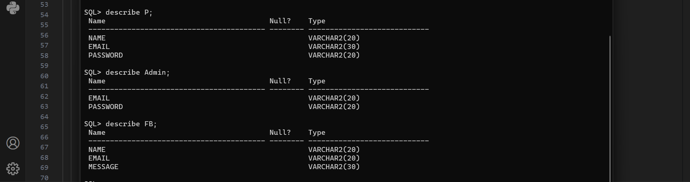

**5.Screenshots:**

**Index.html**

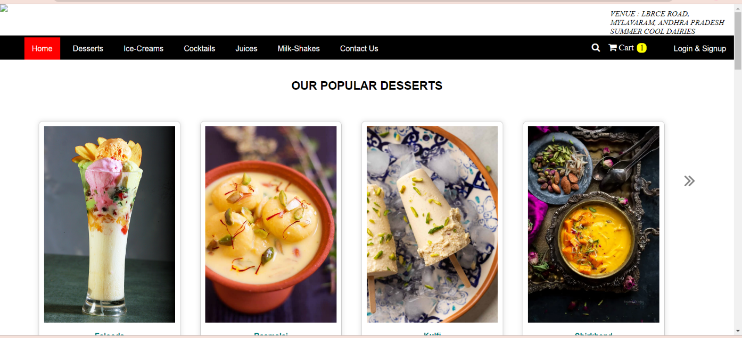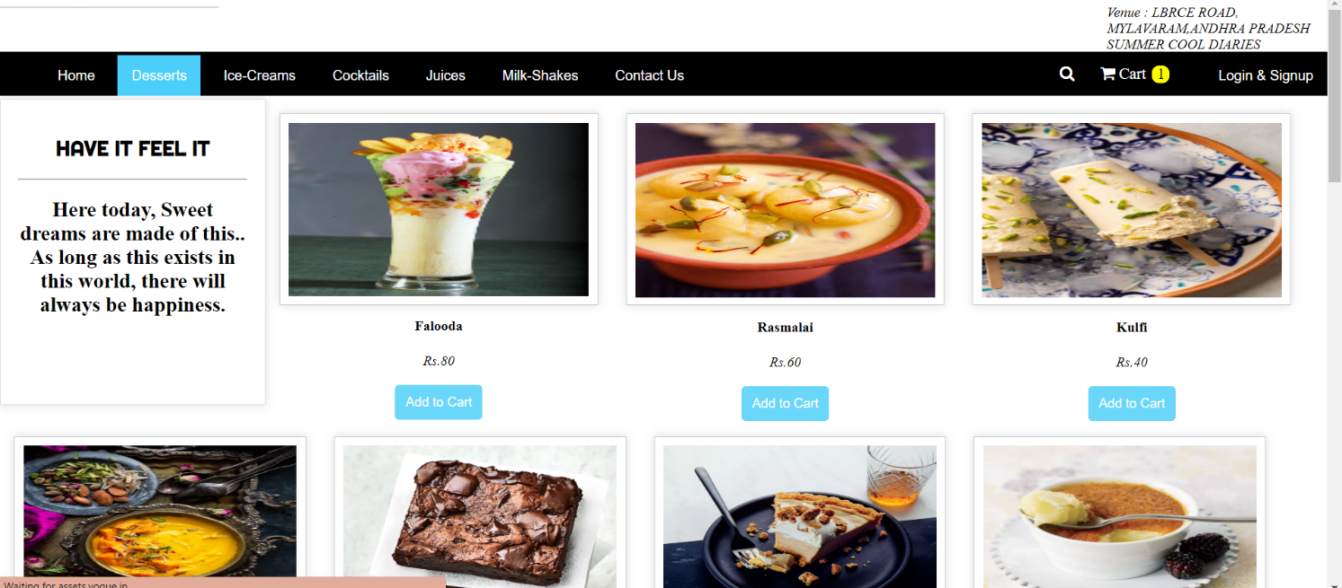

## Milkshakes.html

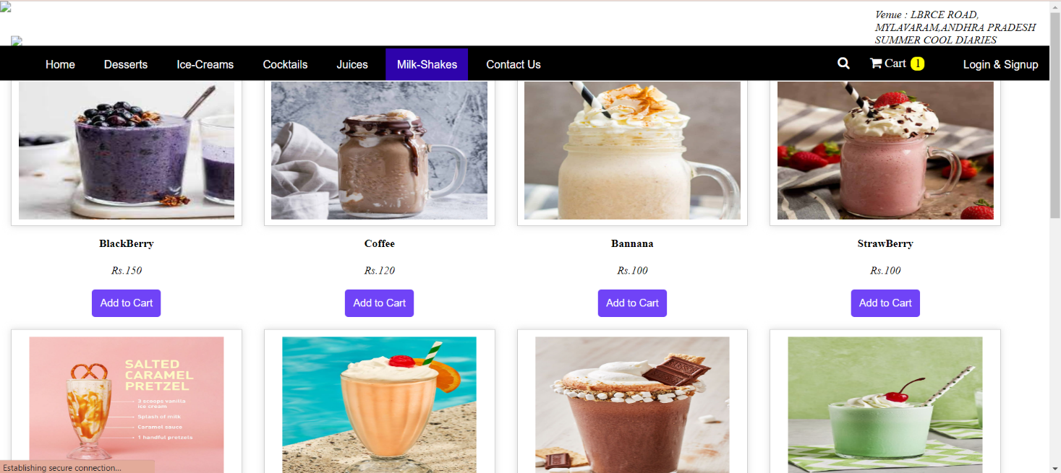

## IceCream.html

## 

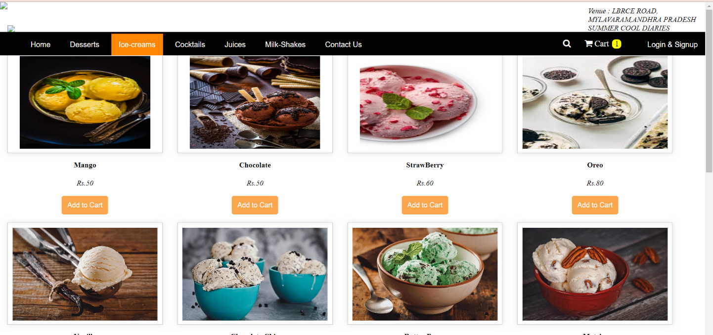

## Cocktails.html

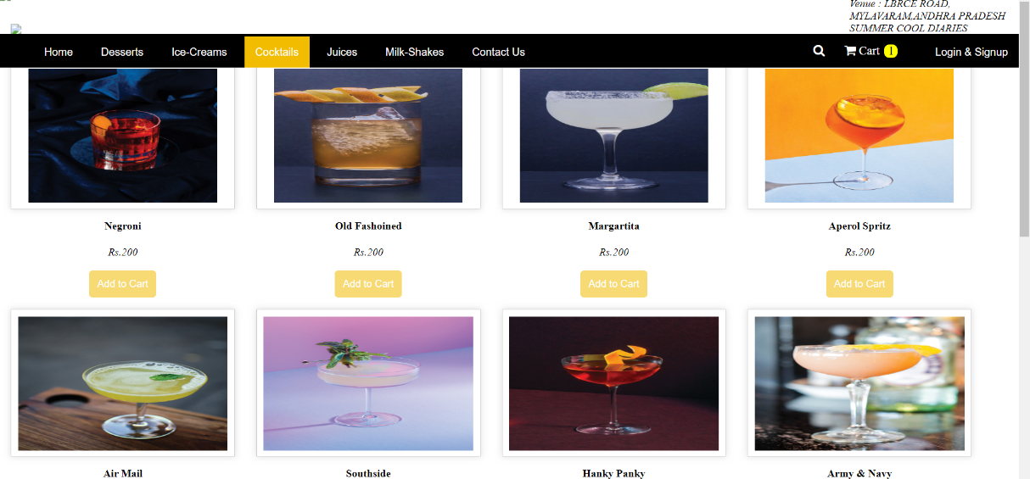

**Juices.html**

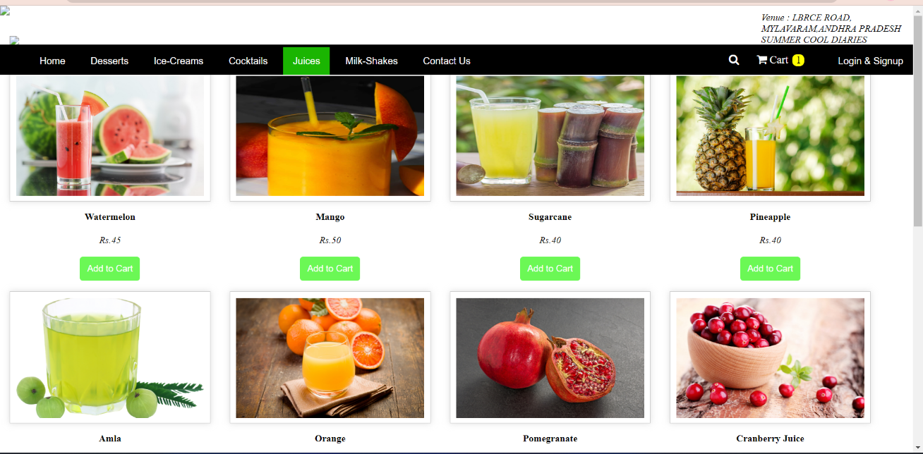

## Cart.html

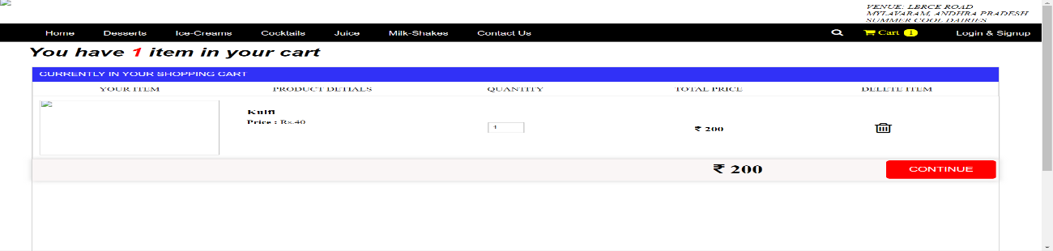

## Contact.html

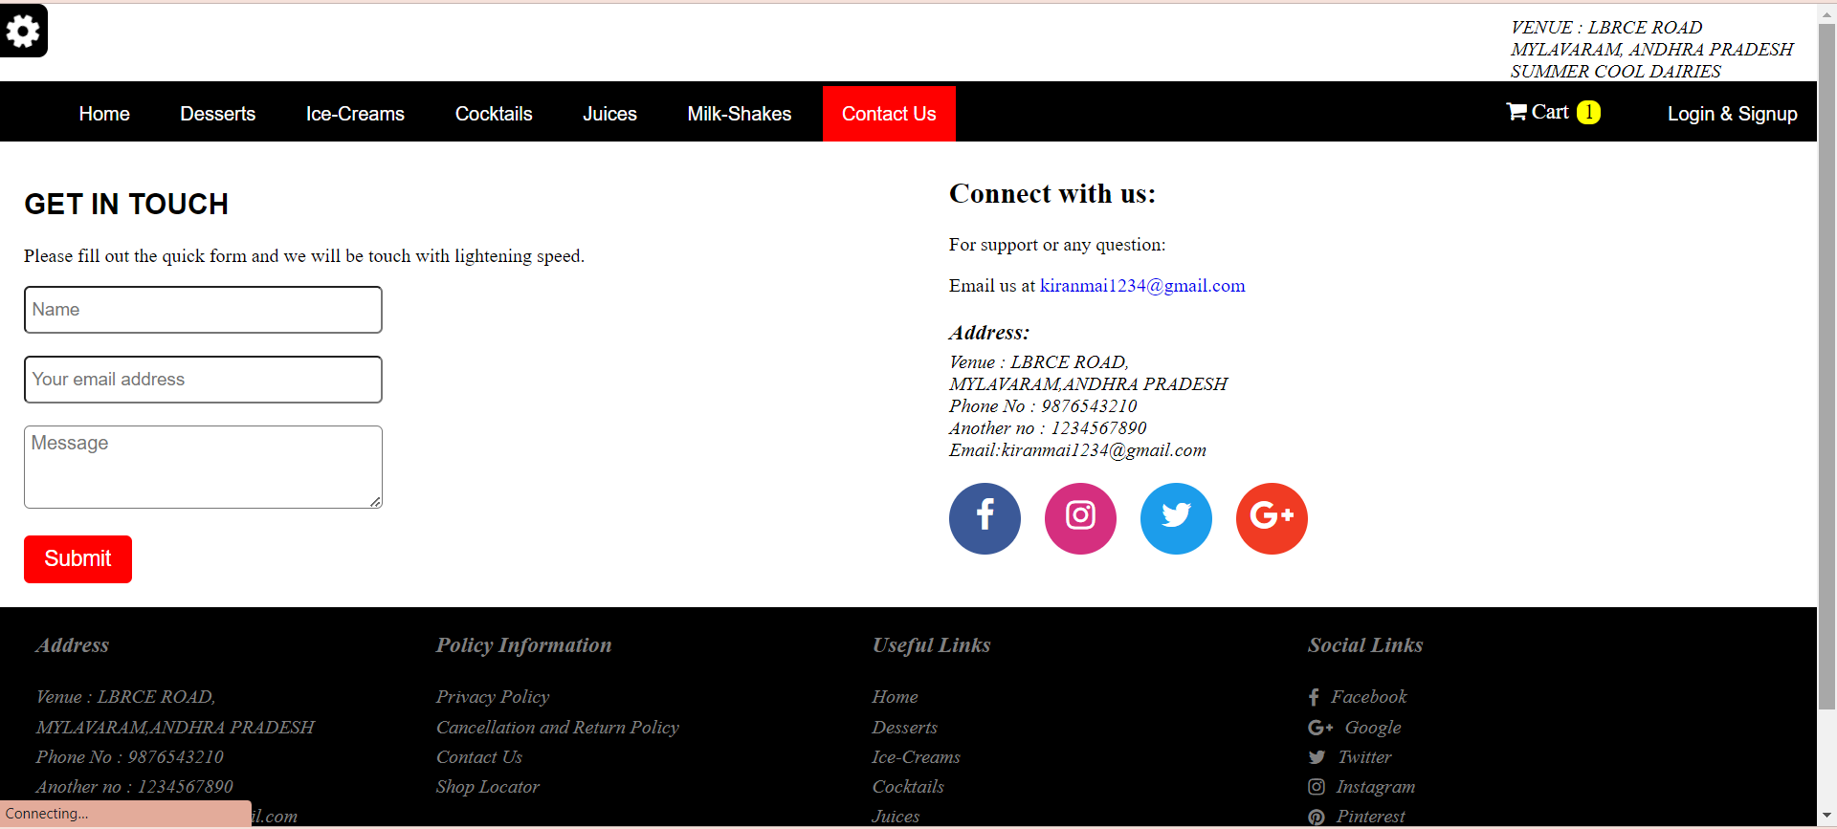

## Order.html

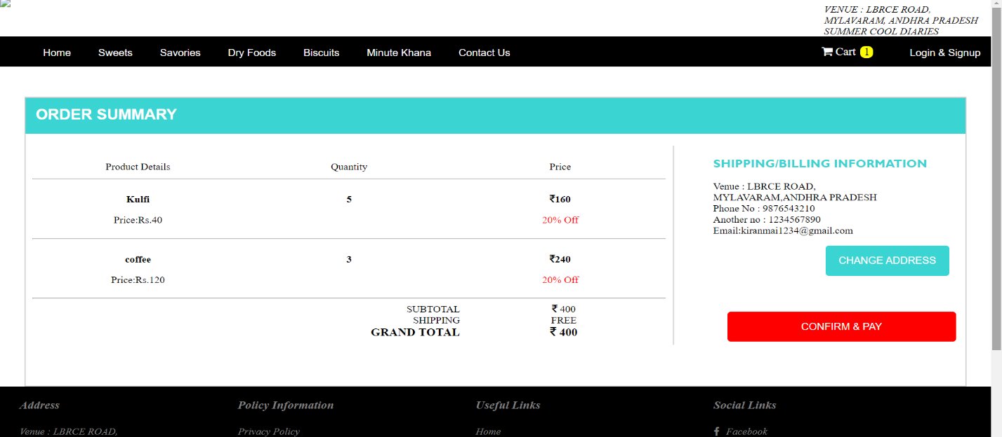

## Login.html

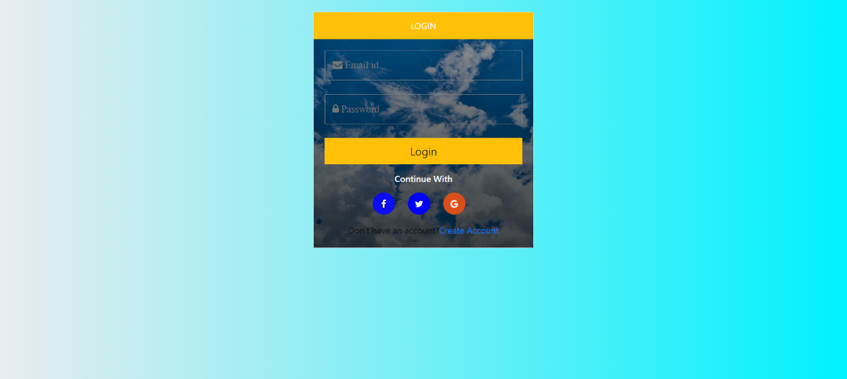

## Signuphtml :

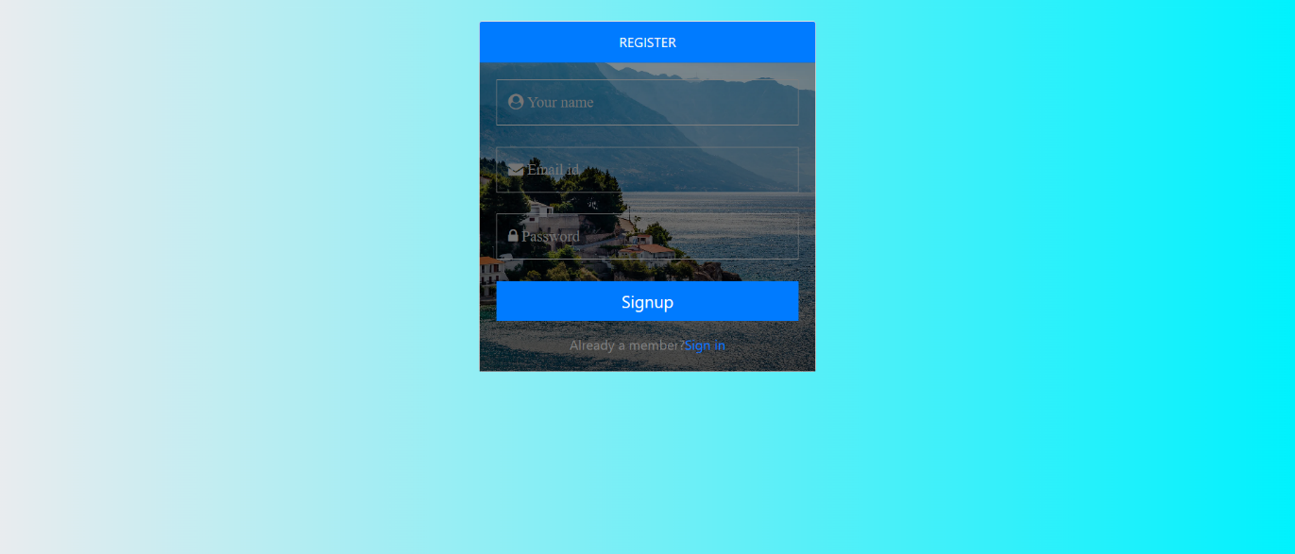

**6.Conclusion:**

So at last the main theme of the application is setting up an Online Ordering system which sets up a business for efficiency , growth and a steady increase in revenue.

->If you were new to this online ordering, This is the good way to encourage customers to order on the site…

## 7.Reference

[**https://www.google.com/**](https://www.google.com/)

**pictures:**[**https://www.pexels.com/**](https://www.pexels.com/)